**Module 4 Activity 3: Creating a NoSQL Database in MongoDB Atlas**

Saurabh Kale

IFT 458/554: Middleware Programming & Database Security

Dinesh Sthapit

Oct 8th, 2023

**Table of Contents**

**Step 1 - Start by setting up additional environment variables in "config.env".** 4

**Step 2 - Create the associated files in the correct folder - loanRoutes.js, loanController.js and loanModel.js in the model folder.** 5

**Step 3 – Server.js file** 10

**Step 4 – Create a folder and name it as dataBaseManager** 10

**Step 5 – Controller file** 11

**Step 6 – App.js file** 14

**Step 7 – The App ran displaying the PORT number and connection** 15

**Handling Error-** 15

**Step 8 – Add a new loan (POSTMAN).** 17

**Step 9 – Add 2 additional loans (POSTMAN).** 18

**Step 10 – Get Users To get all users, enter http://localhost:<PORT-NUMBER>/loans/ as the address.** 20

**Step 11 – Get a Specific User (POSTMAN) Get the data of a specific user by entering this URL: http://localhost:<PORT_NUMBER>/loans/:id** 24

**Step 12 – Change an Existing Loan (POSTMAN) Change an existing Loan by using the PUT verb. Then change the value of the JSON object. The URL is the same as when we fetched the specific Loan.** 25

**Step 13 – To delete a loan, we only need to change the verb to DELETE. We can verify that the user is gone by fetching all the loans. Now Verify that you have a fully working express backend connected to a MongoDB database.** 26

**Git Repository-** 28

# **Step 1 - Start by setting up additional environment variables in "config.env".**

*Screen shot showing the config.env file with all the environment variables.*

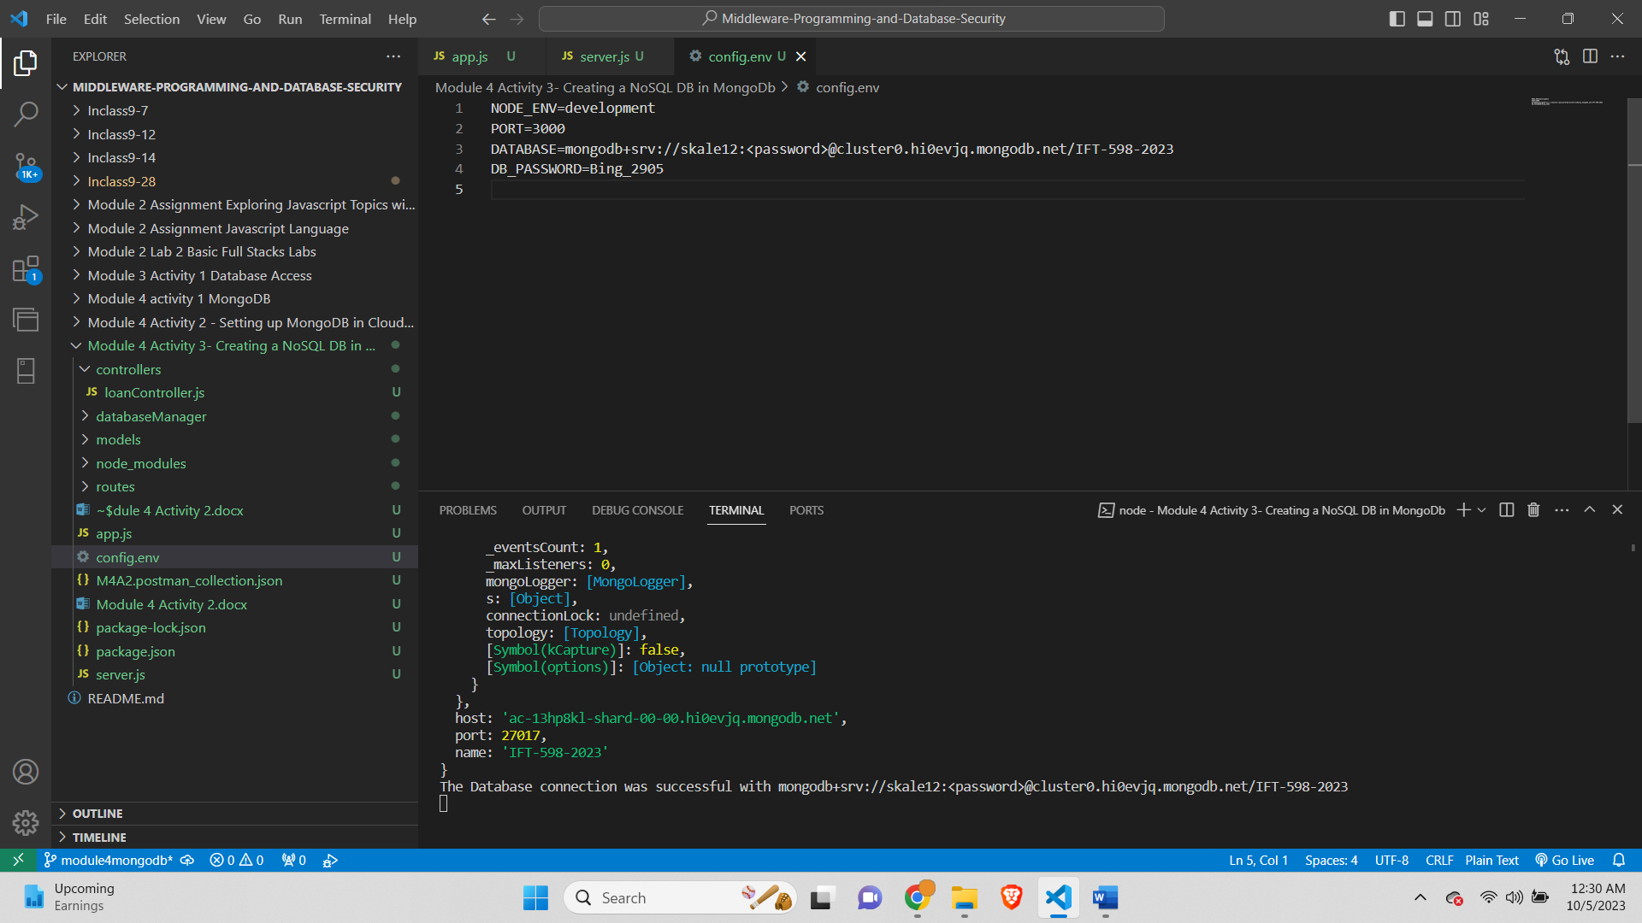

# **Step 2 - Create the associated files in the correct folder - loanRoutes.js, loanController.js and loanModel.js in the model folder.**

Screenshot of the **loanRouter.js** file

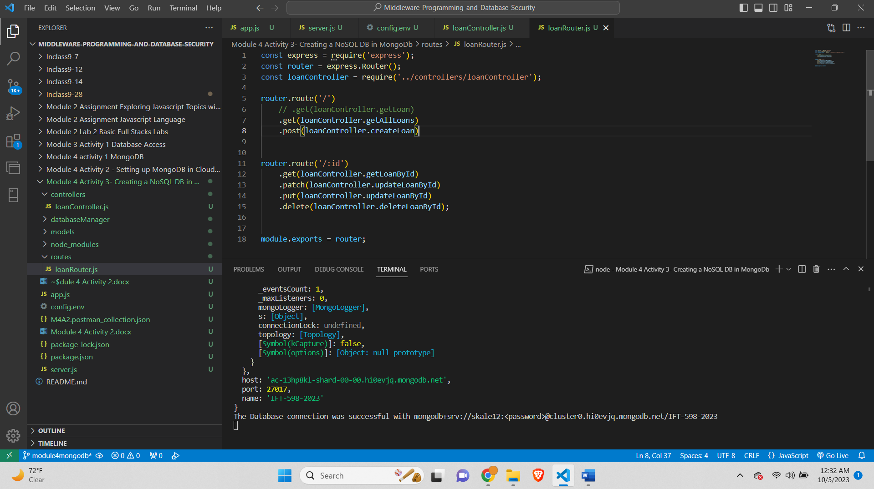

Screenshot of the **loanController.js** file

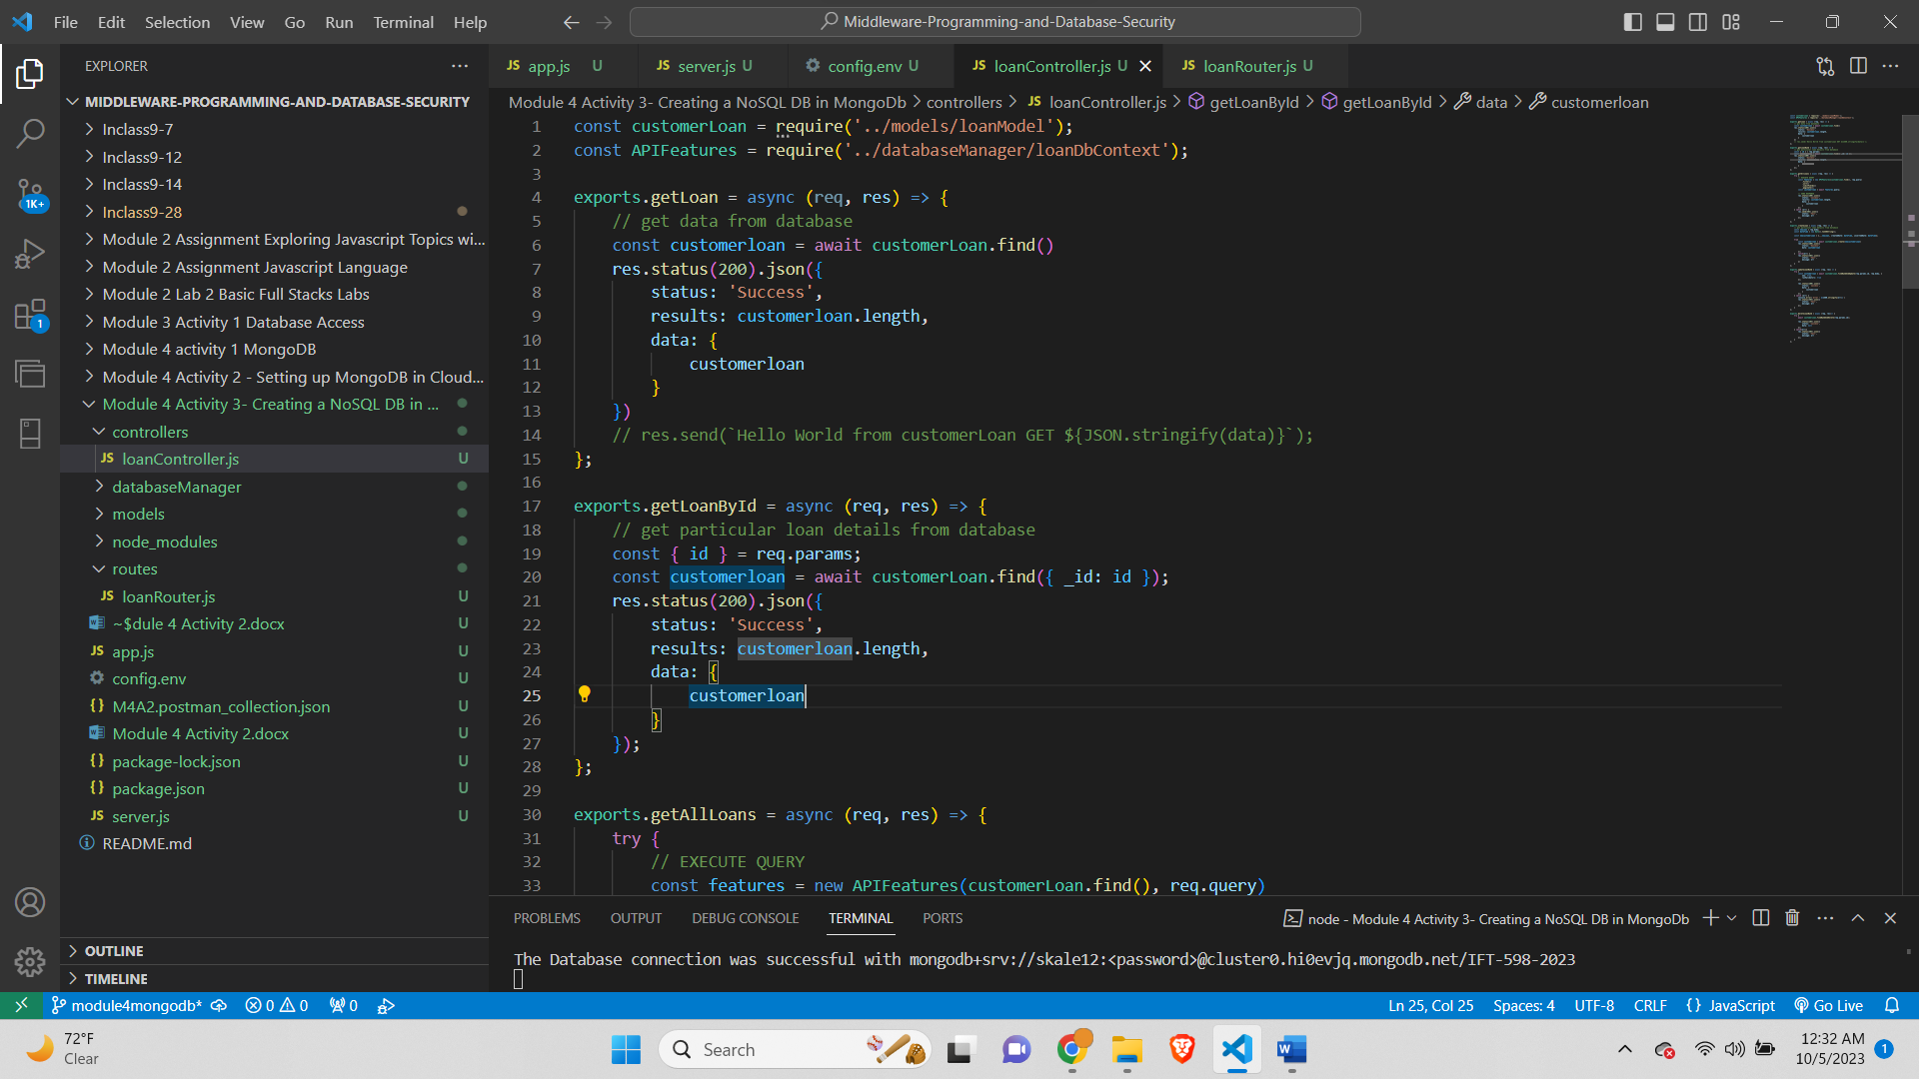

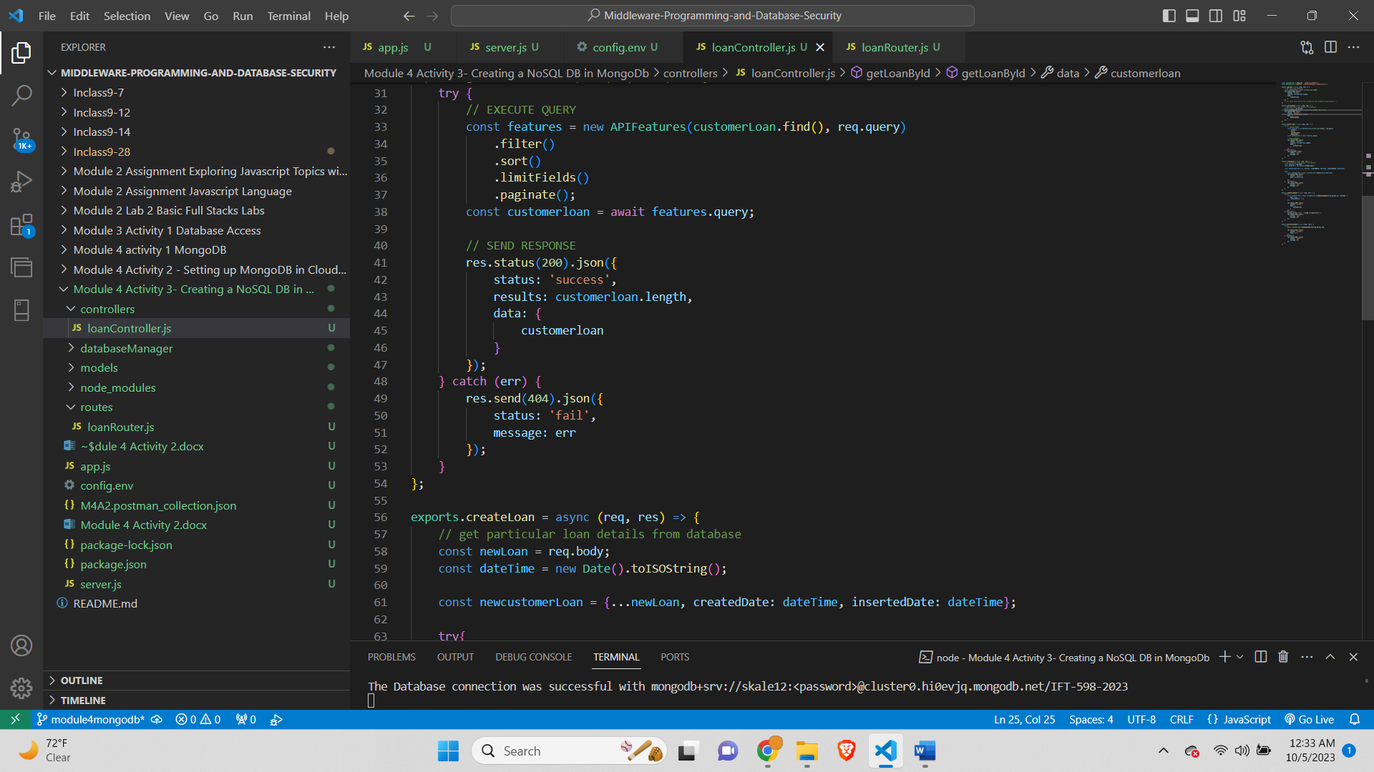

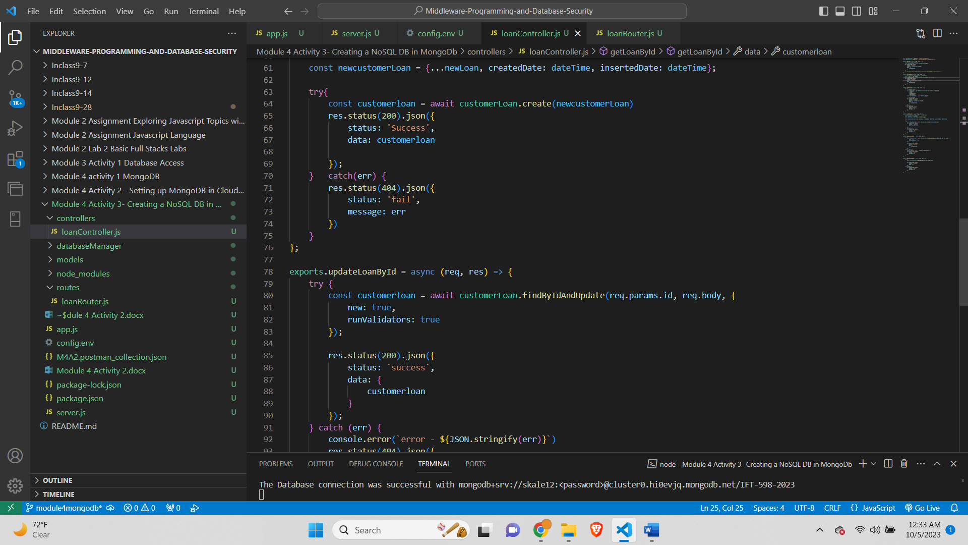

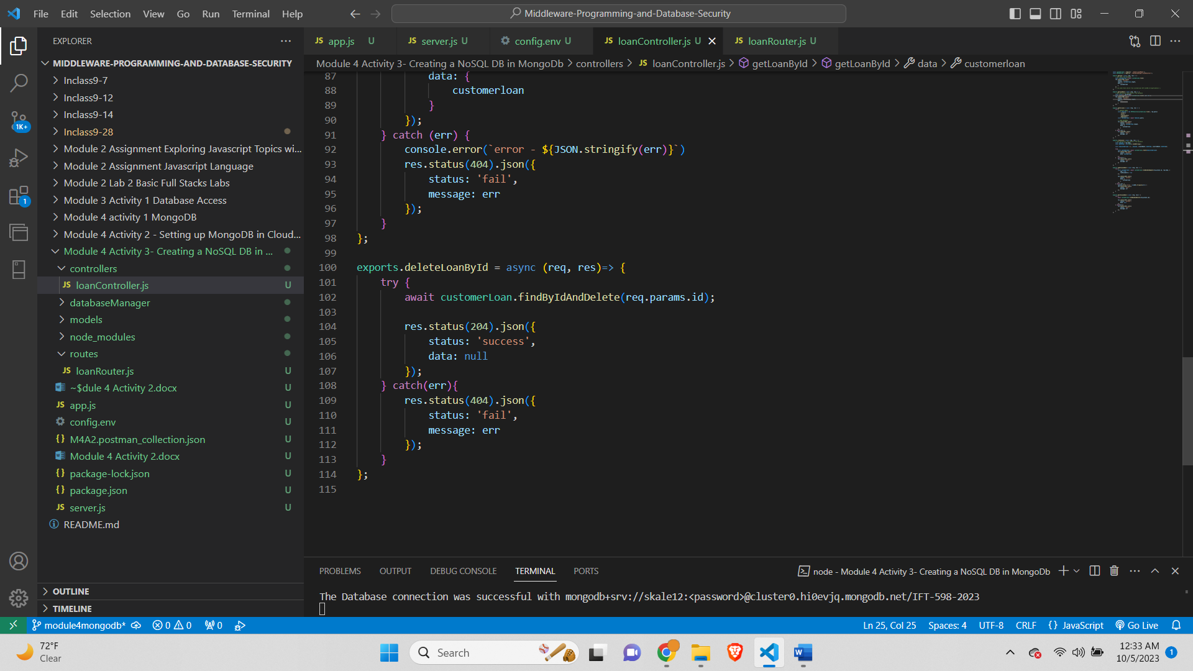

**Screenshot of loanModel.js file-**

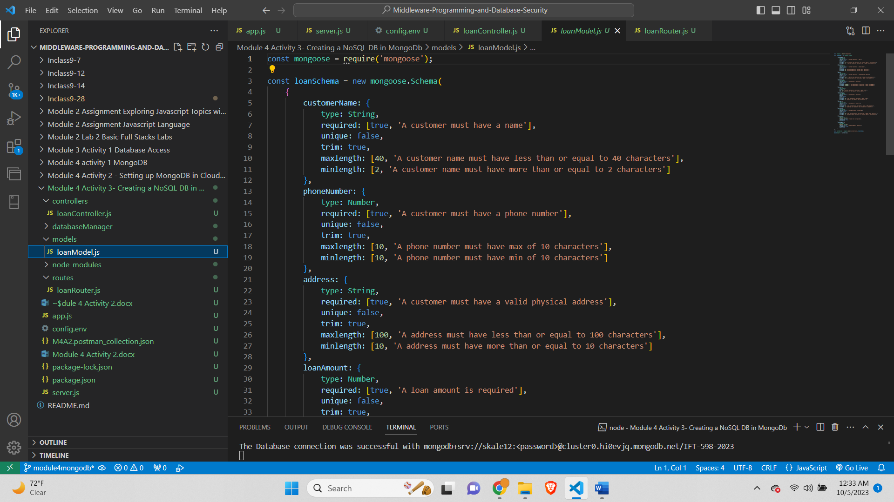

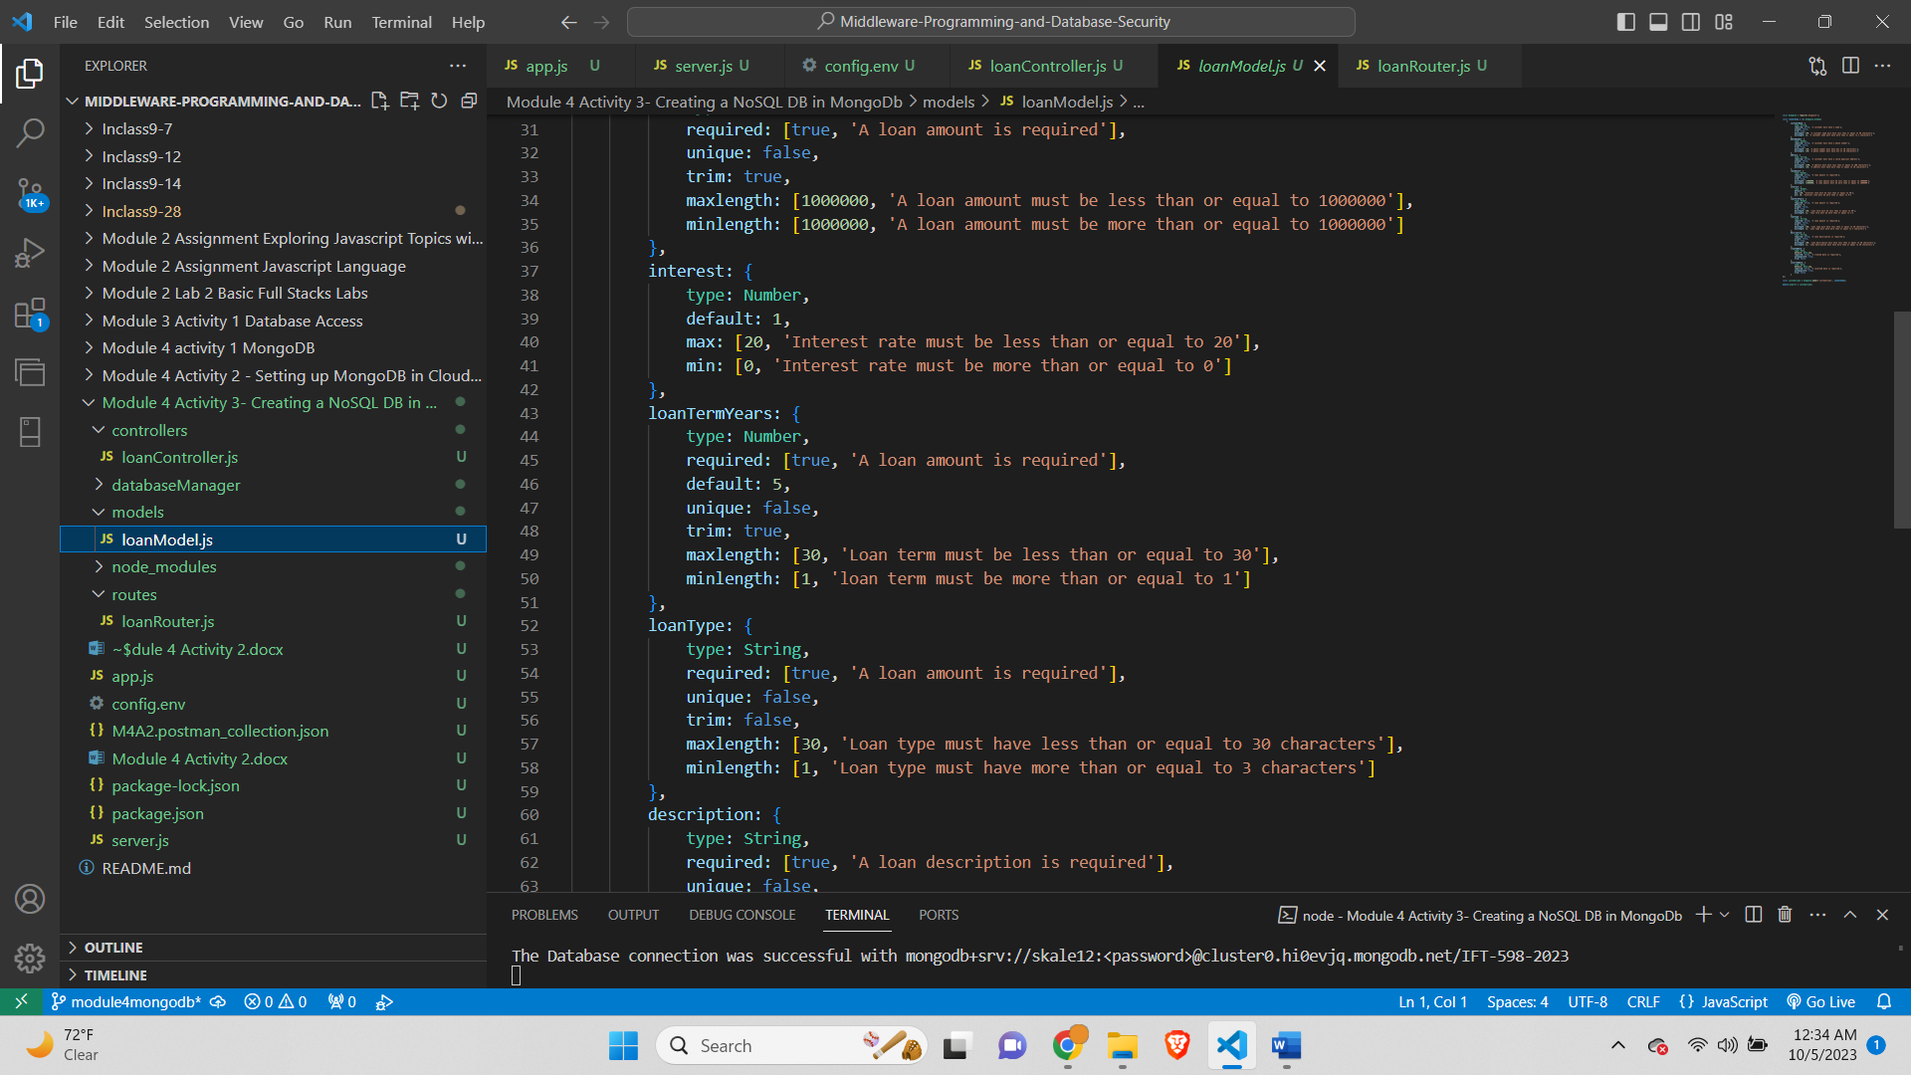

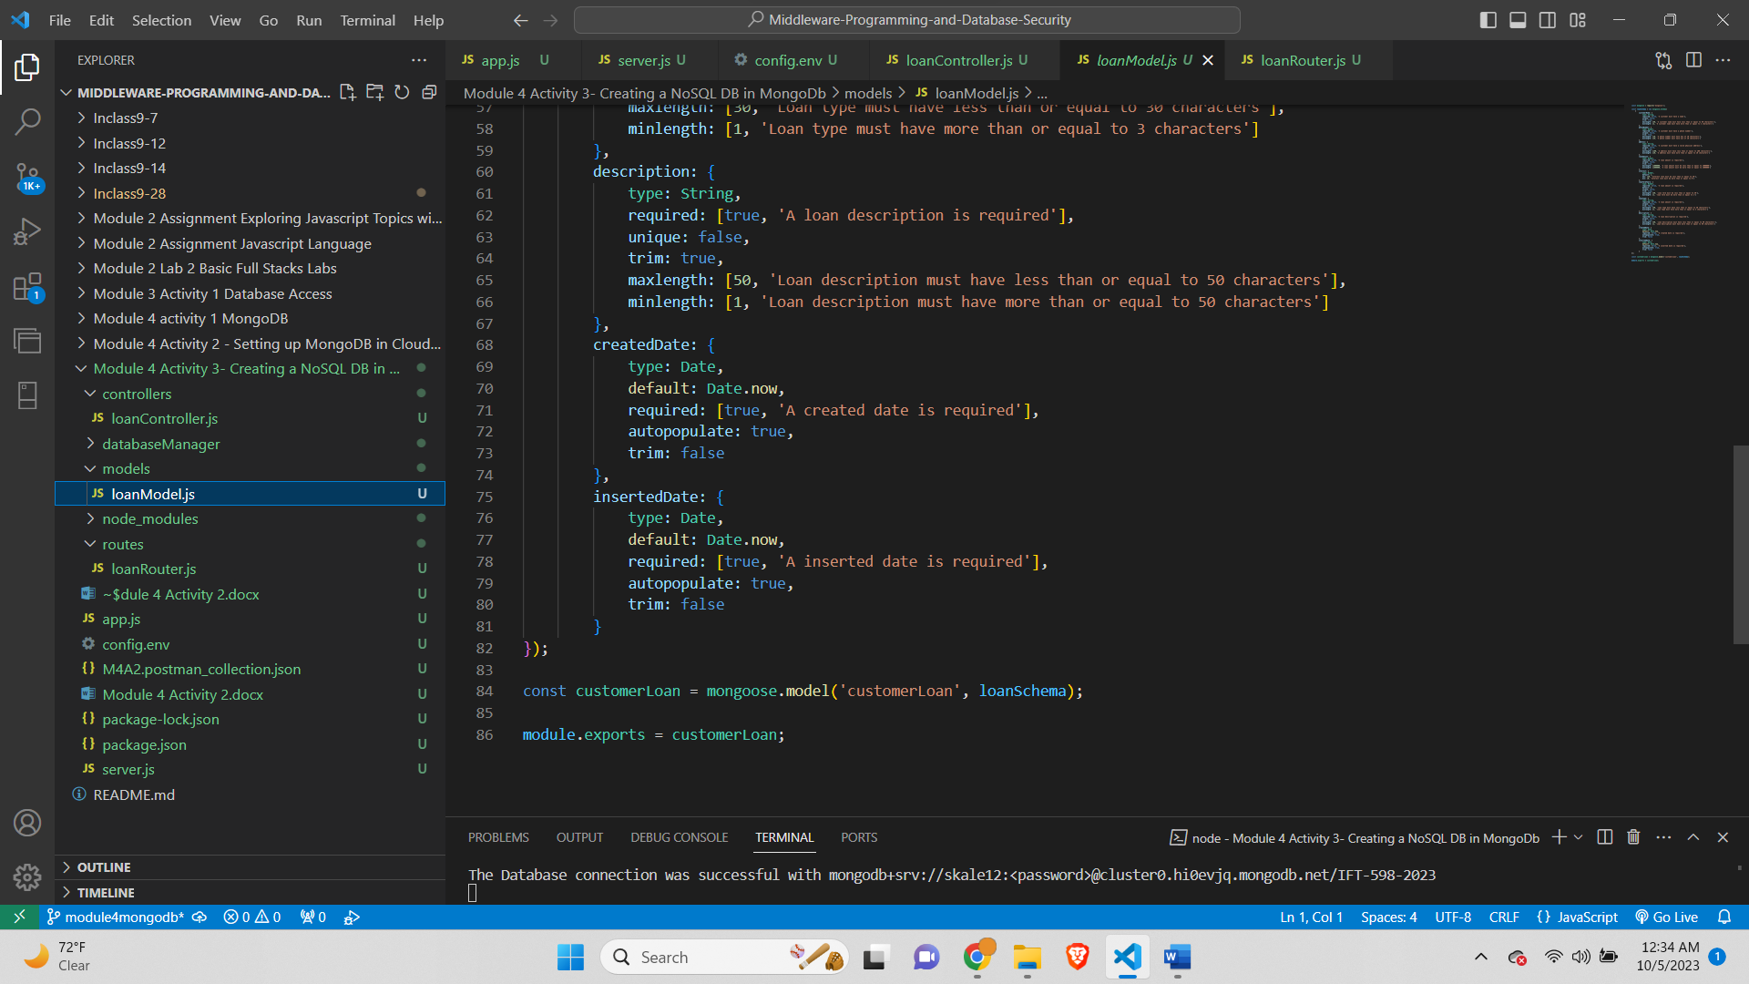

# **Step 3 – Server.js file**

**Screenshot of the server.js file-**

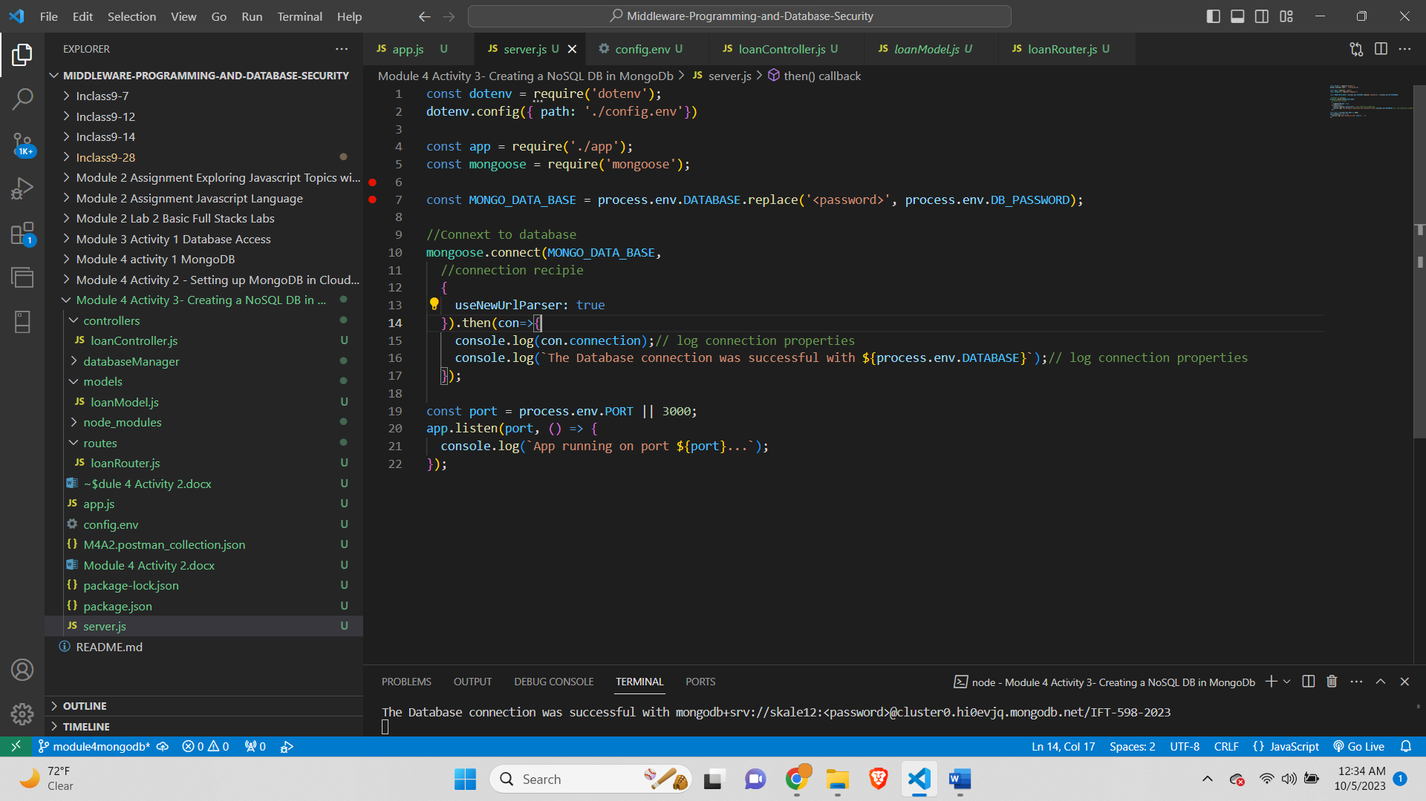

# **Step 4 – Create a folder and name it as dataBaseManager**

*Screenshot of the dataBaseManager folder and the loanDbContext.js file*

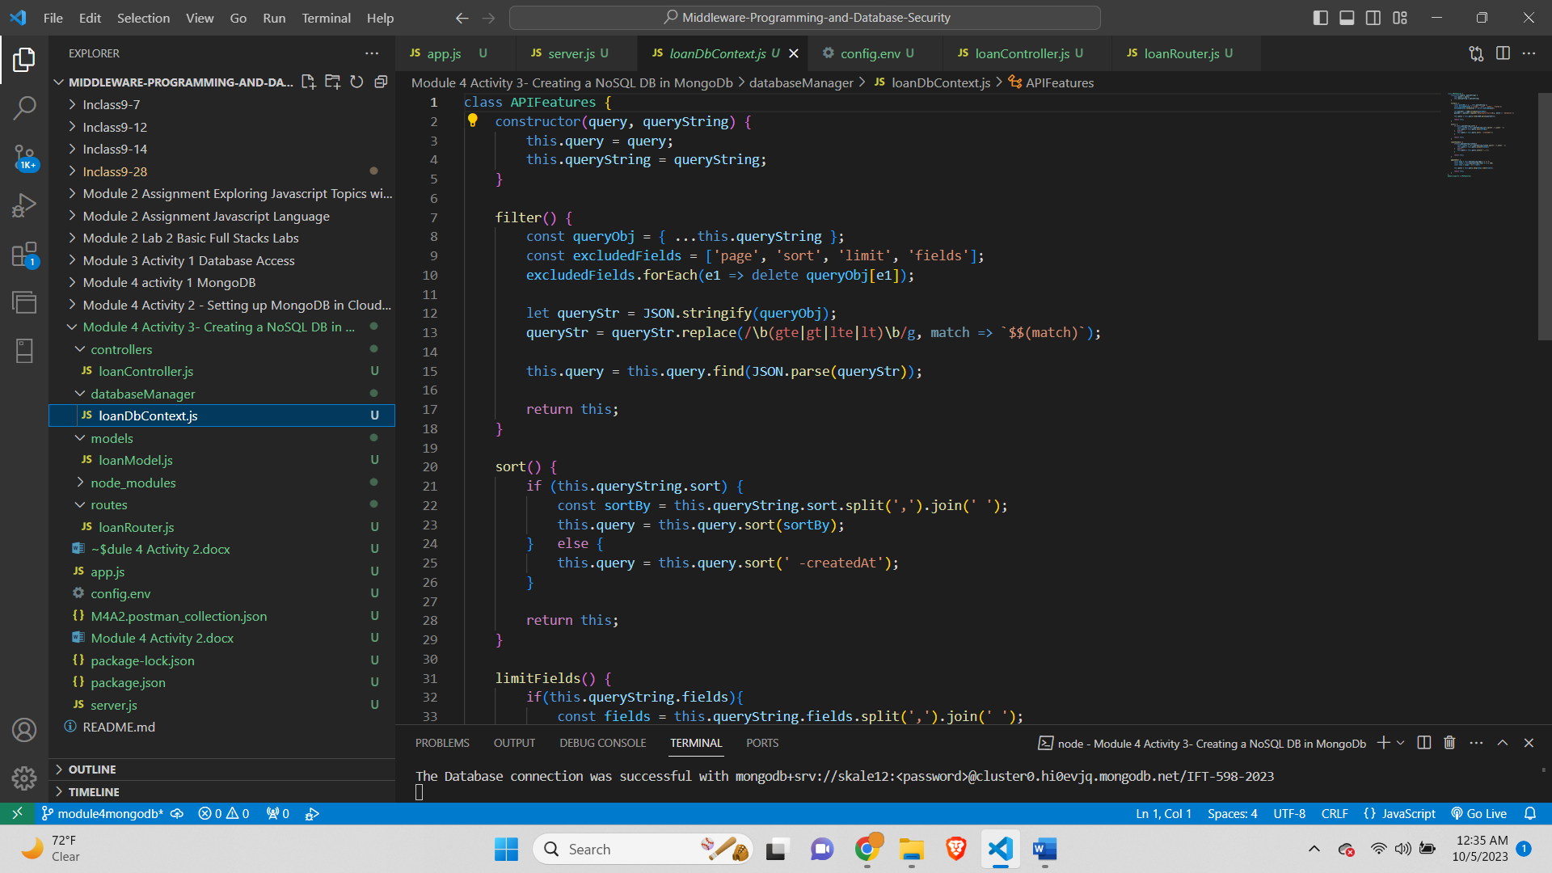

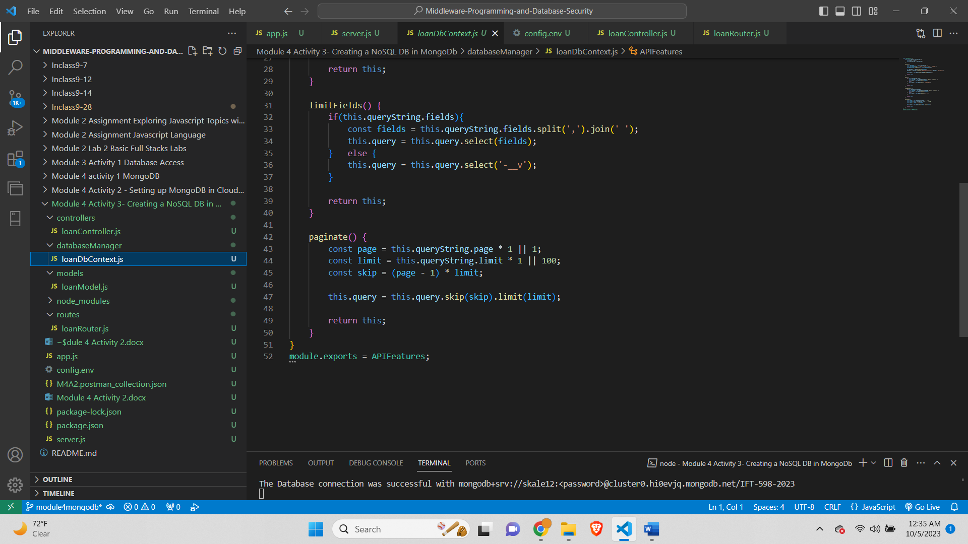

# **Step 5 – Controller file**

***Screenshot of the loanController.js***

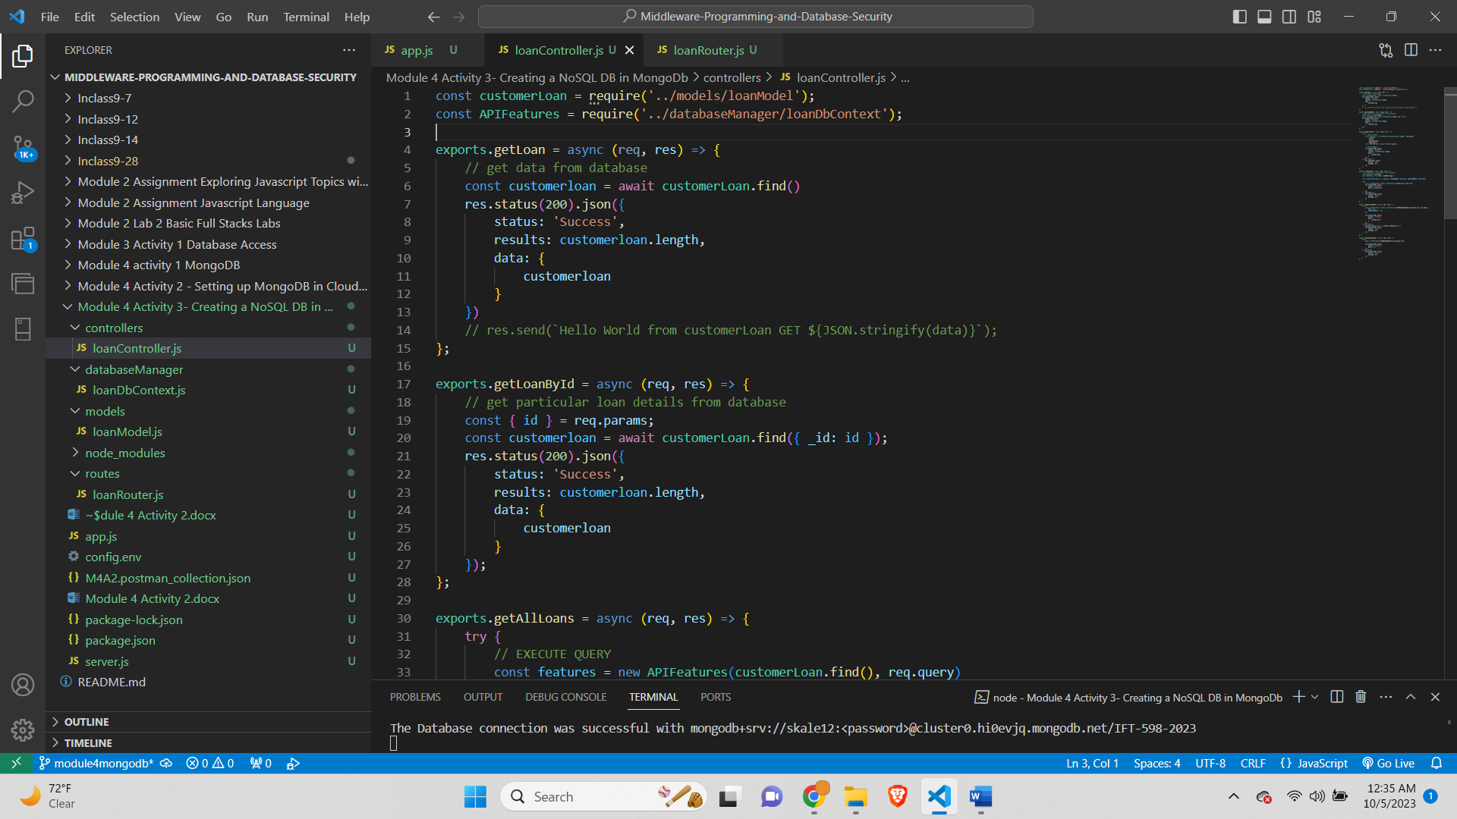

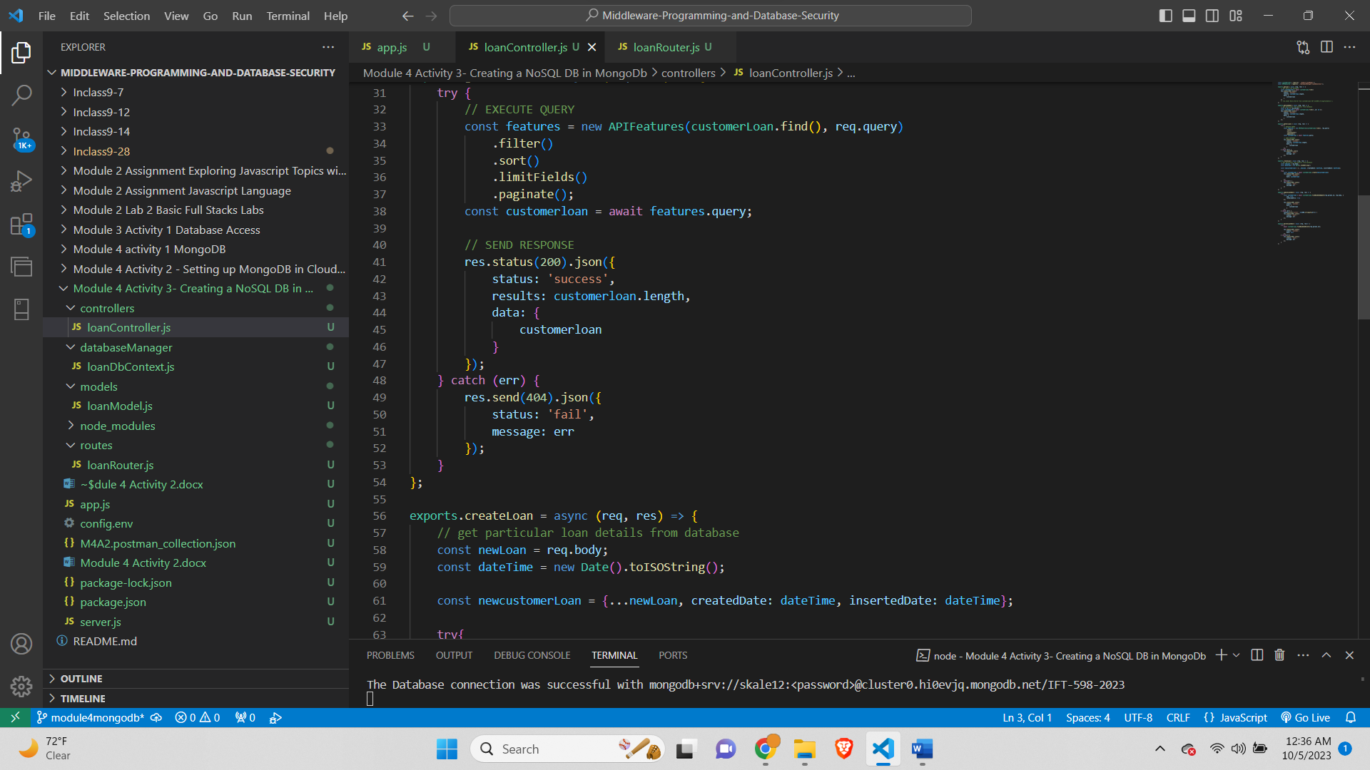

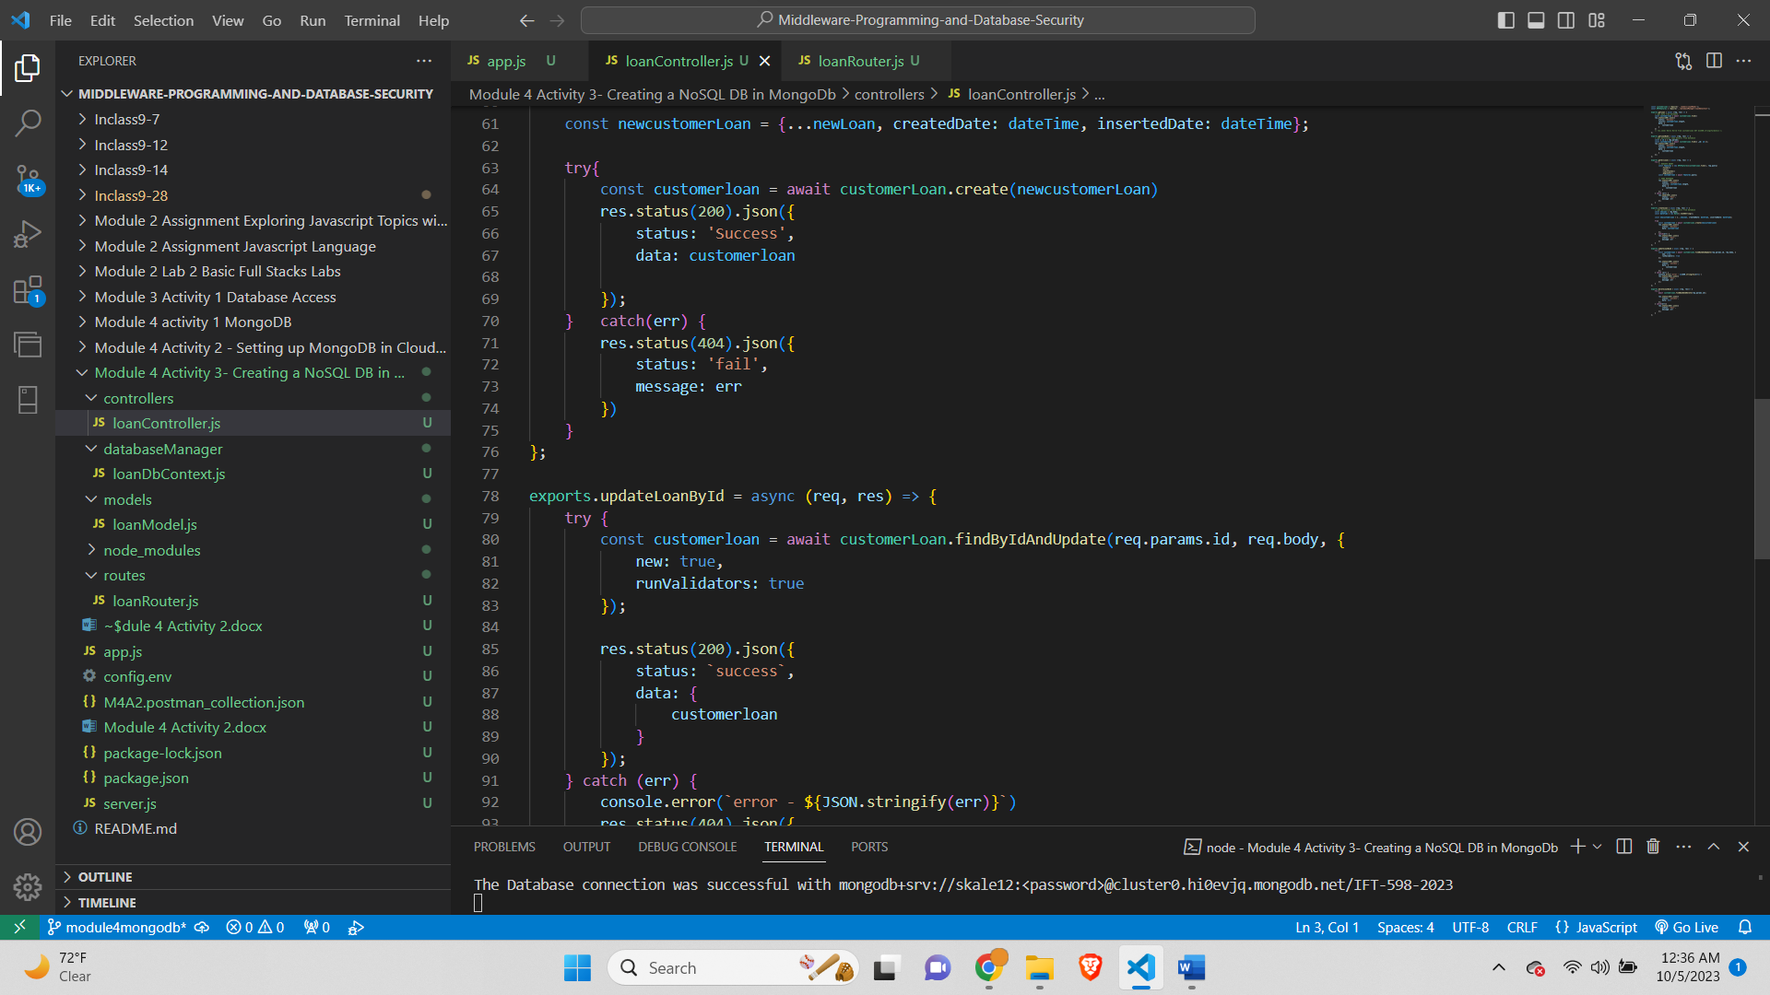

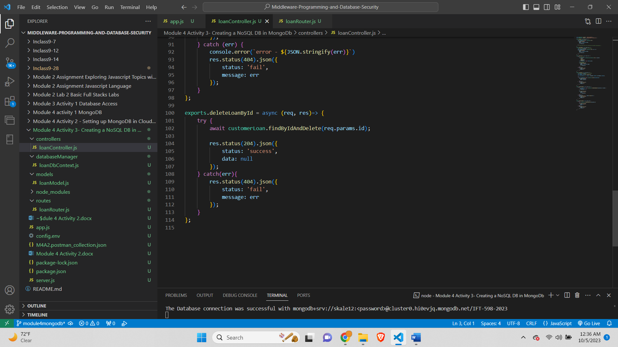

# **Step 6 – App.js file**

*Screenshot of the app.js file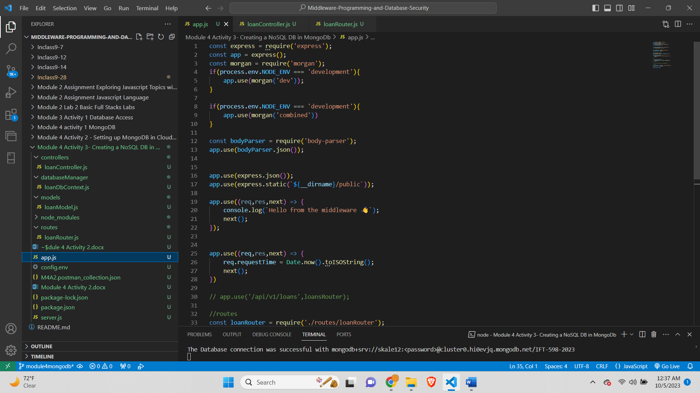*

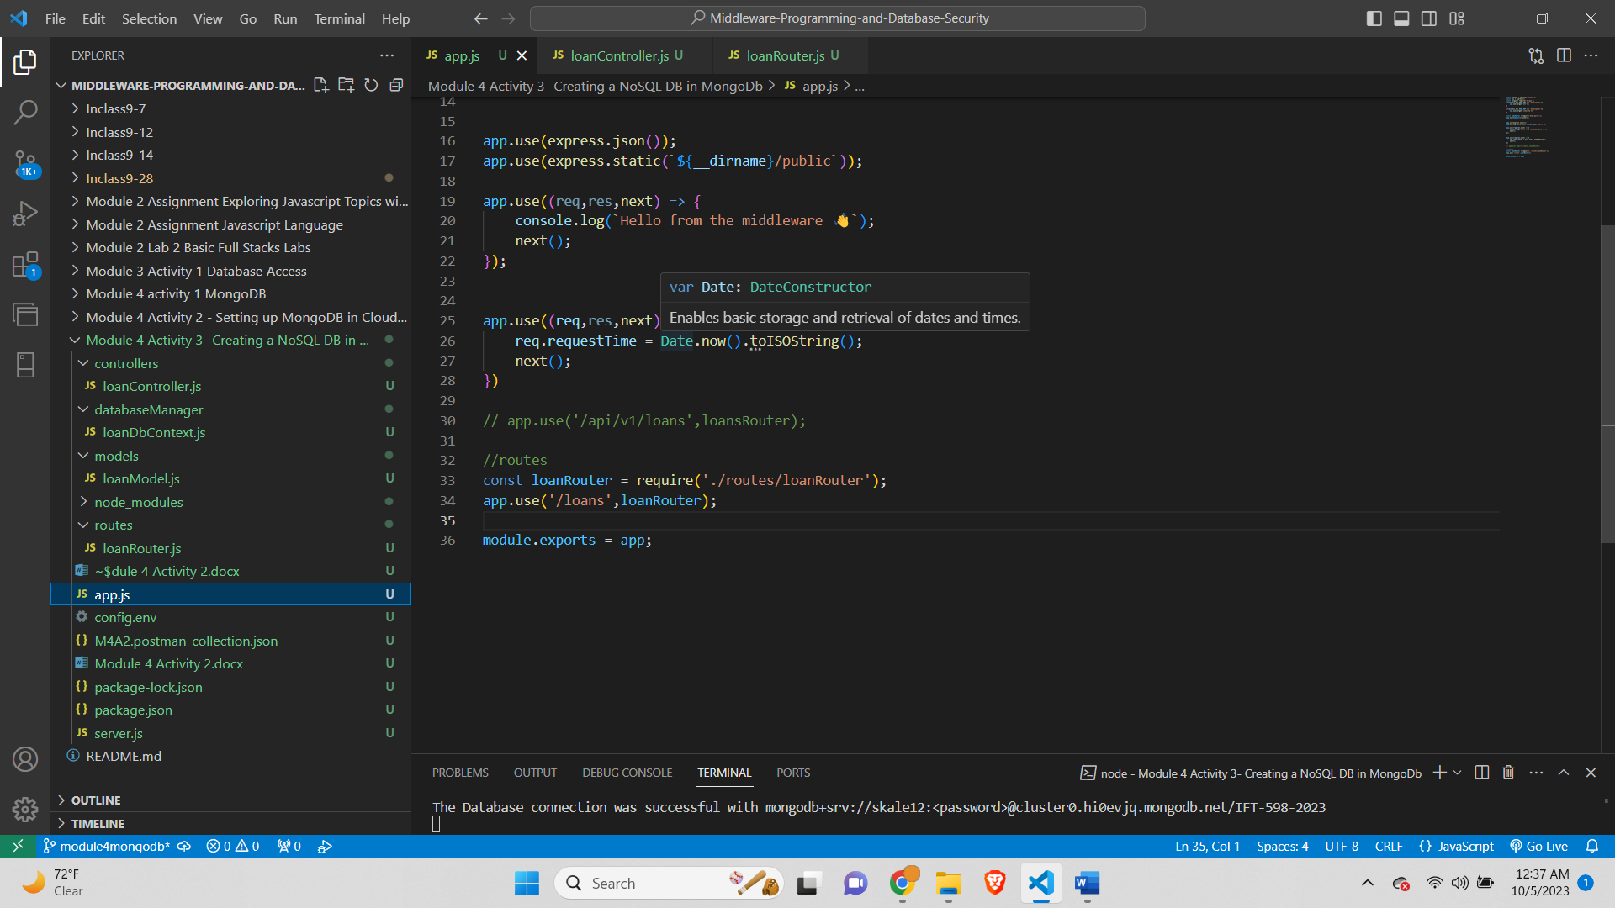

# **Step 7 – The App ran displaying the PORT number and connection**

*Screenshot of the output displaying the port number and the message showing the DB connection*

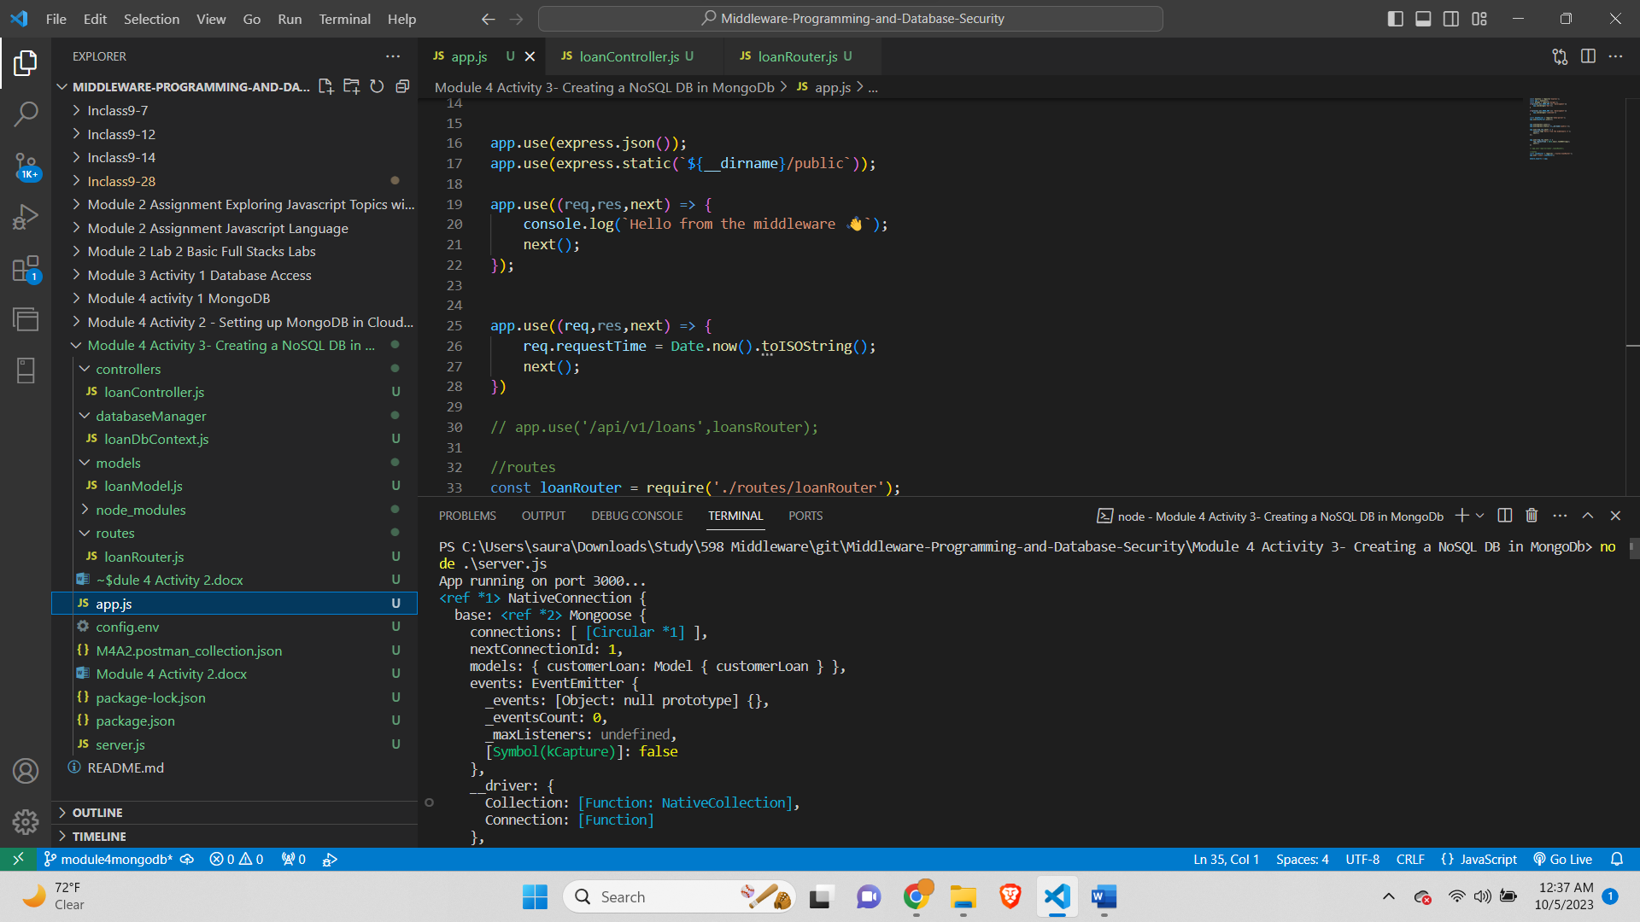

# **Handling Error-**

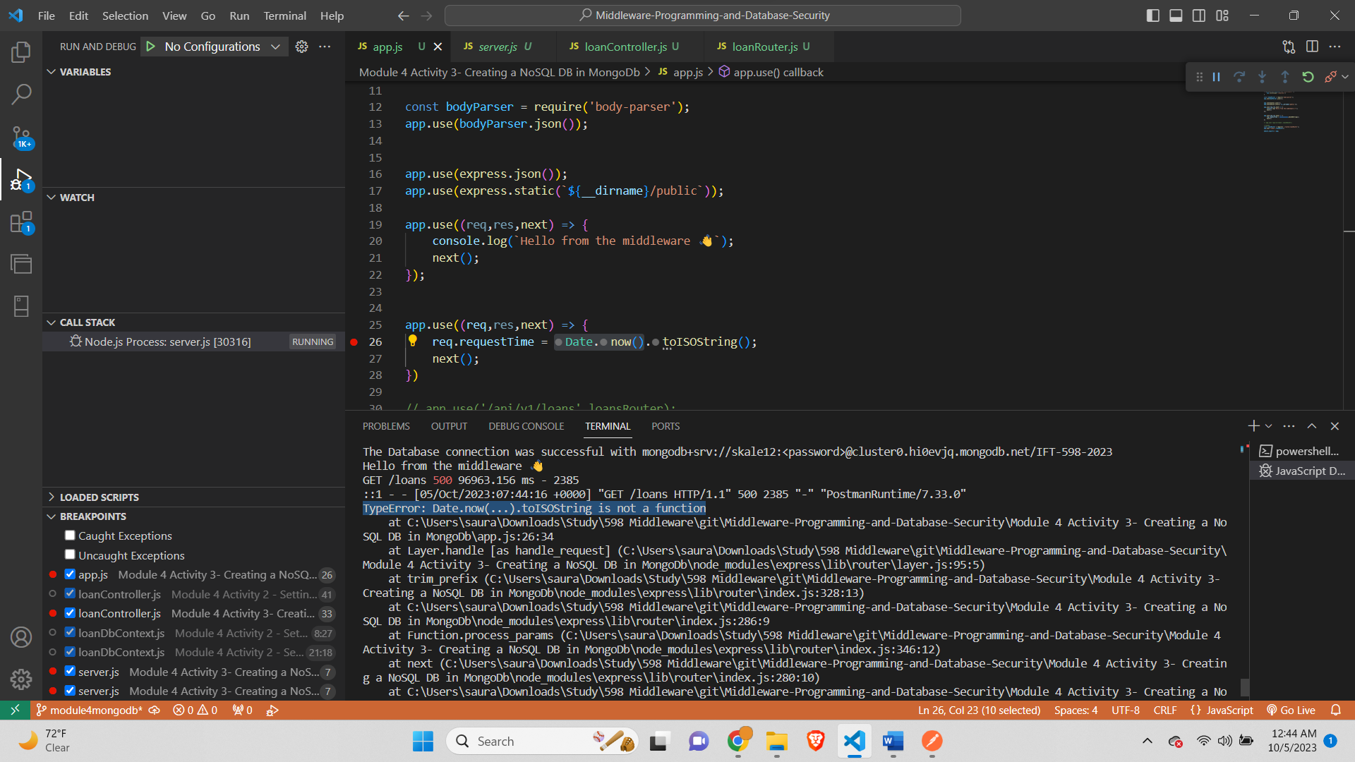

*To handle error we change toISOString() to toString() and successful get request-*

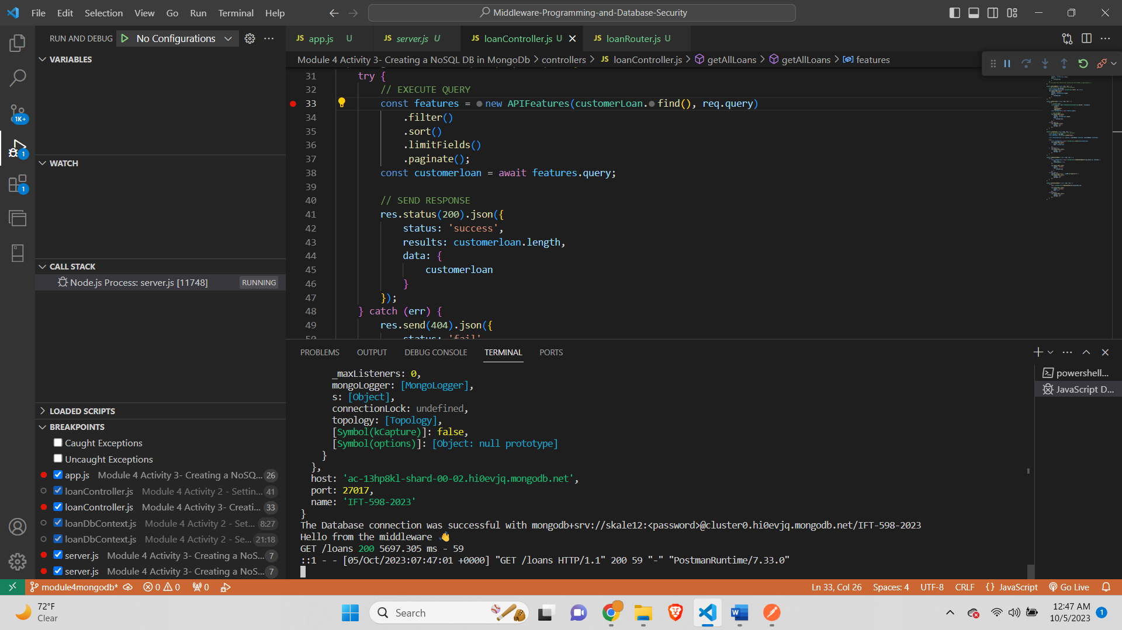

# **Step 8 – Add a new loan (POSTMAN).**

*Screenshot of the postman showing the addition of new loan successfully*

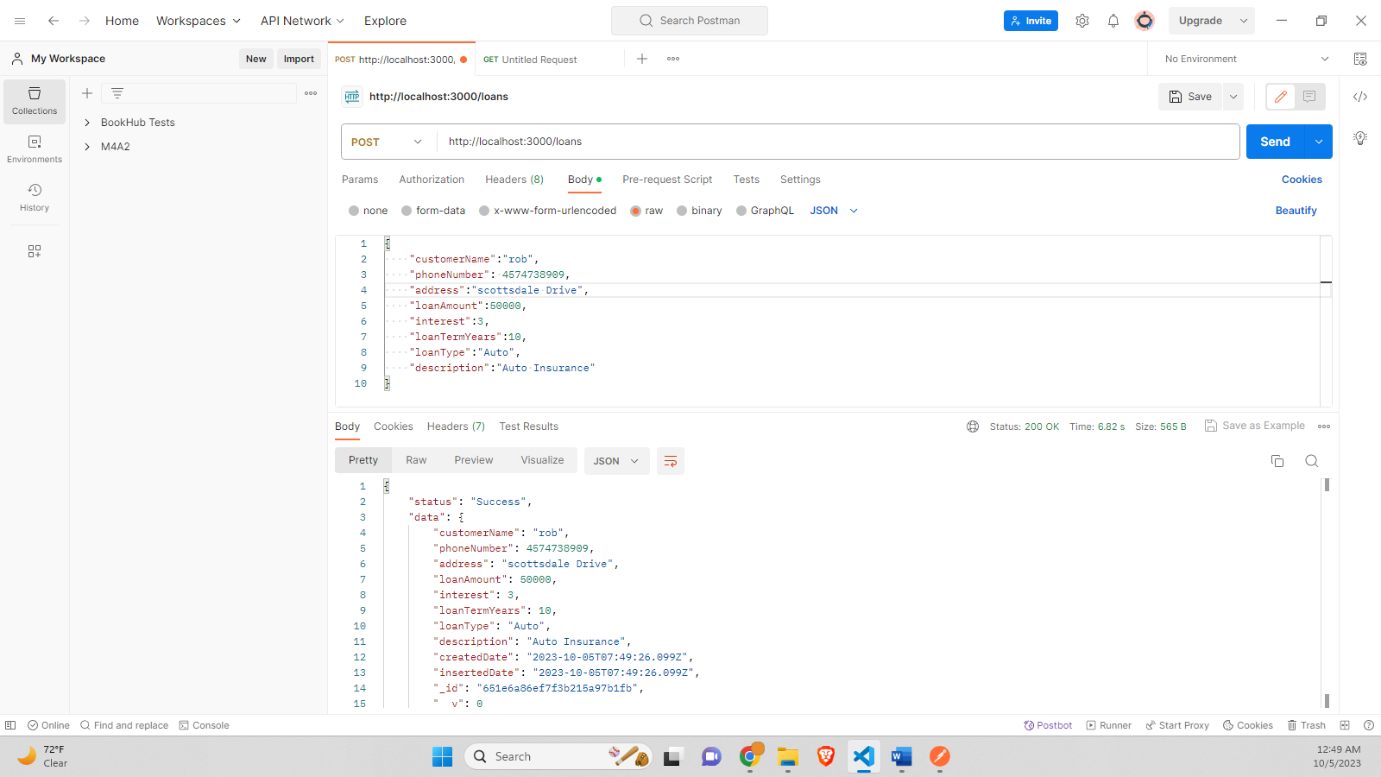

**Loan document successfully added to the Mongo DB**

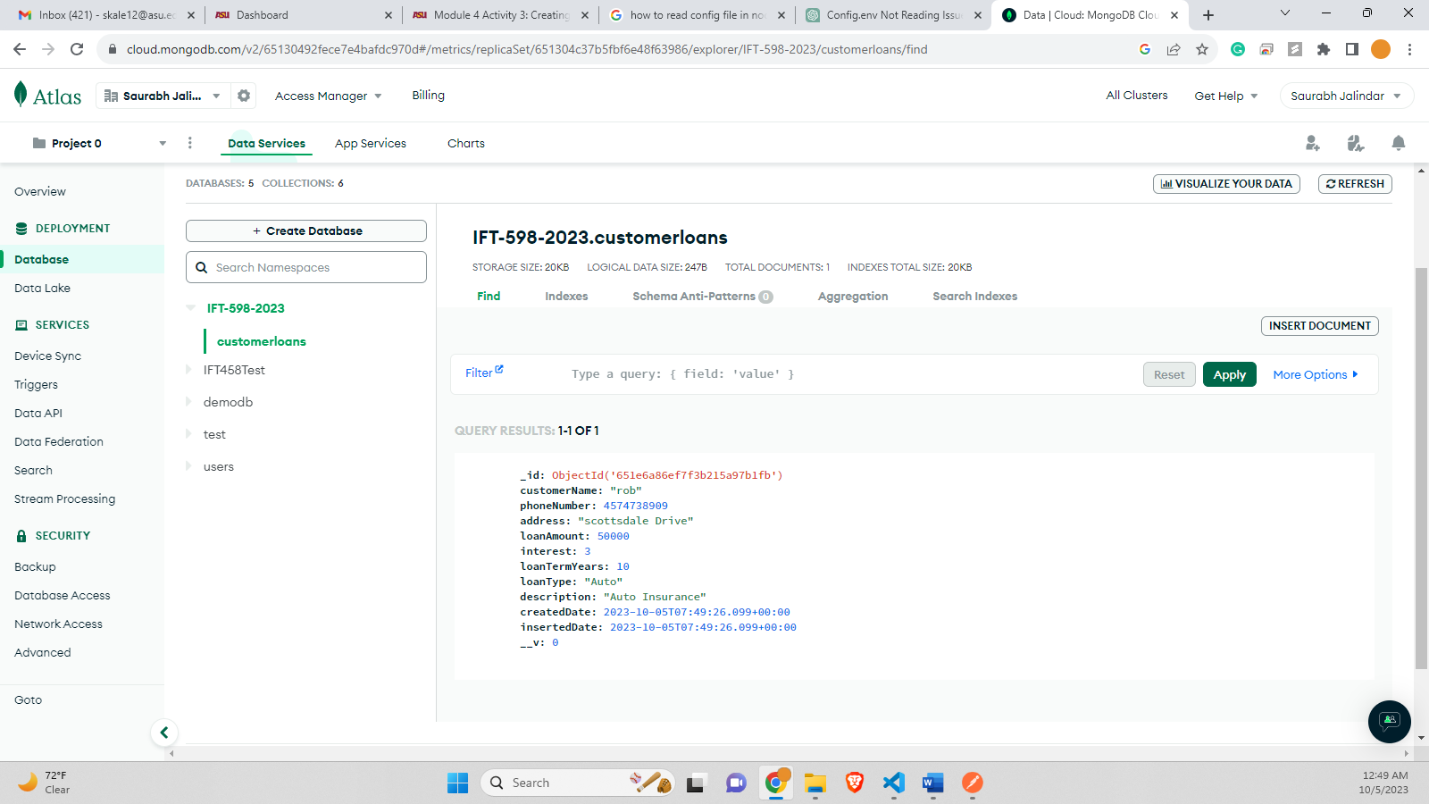

# **Step 9 – Add 2 additional loans (POSTMAN).**

*Screenshot of the postman showing successful addition of 2 new loans*

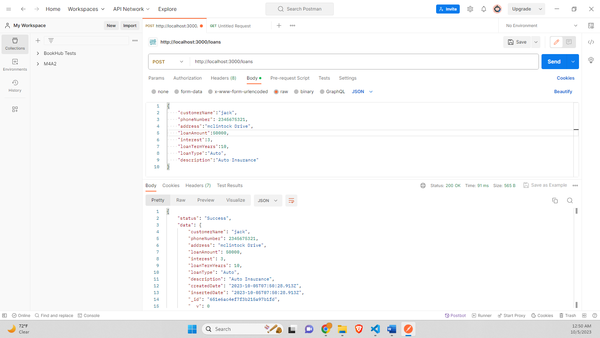

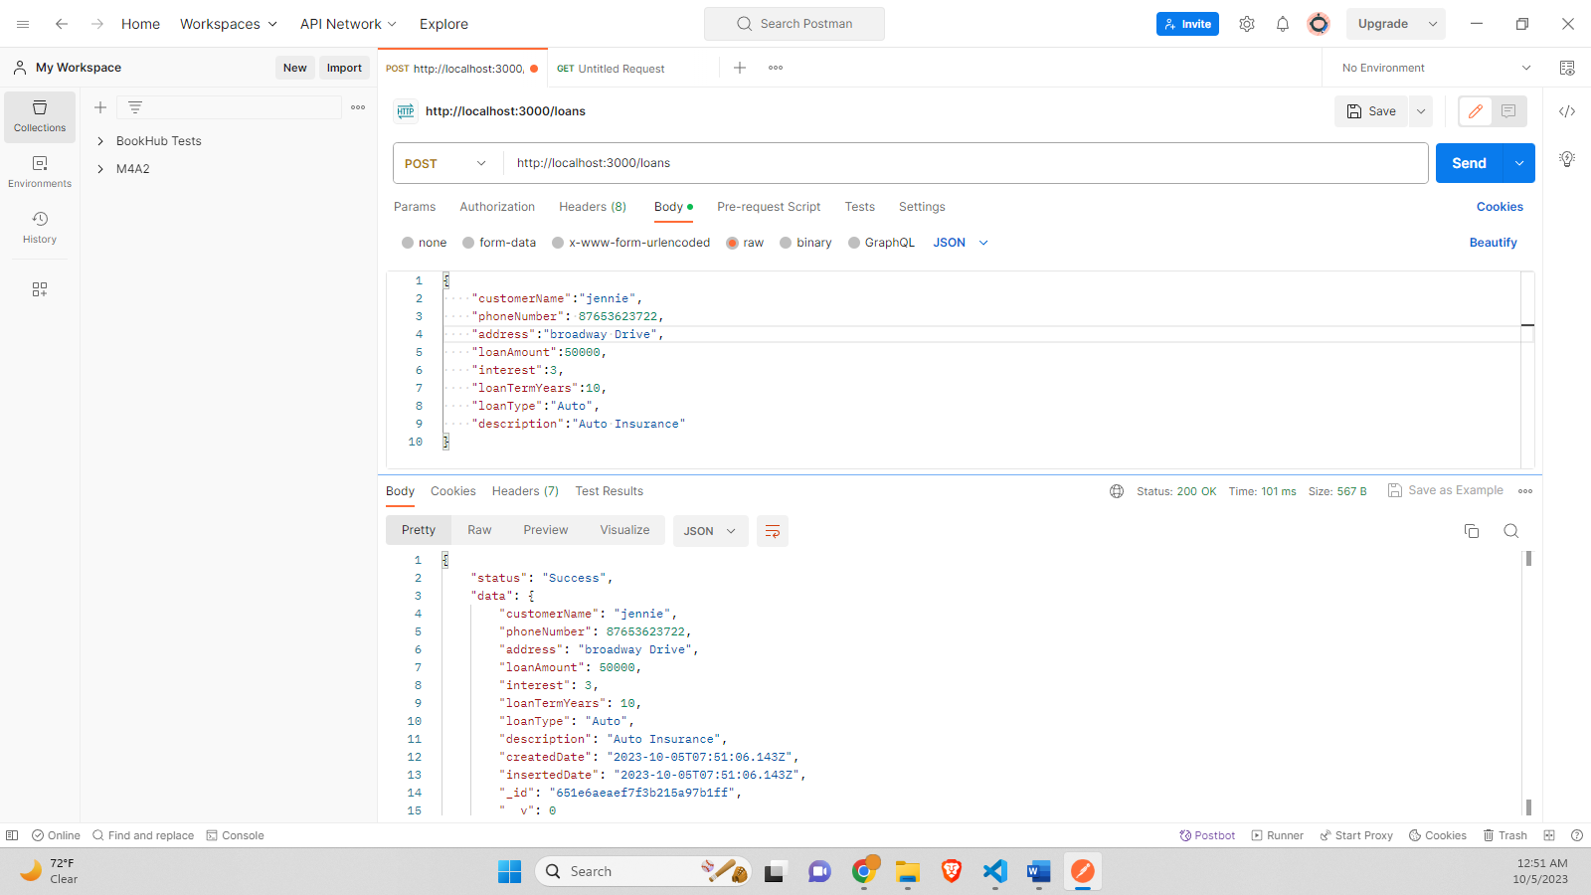

*Screenshot of the Terminal output*

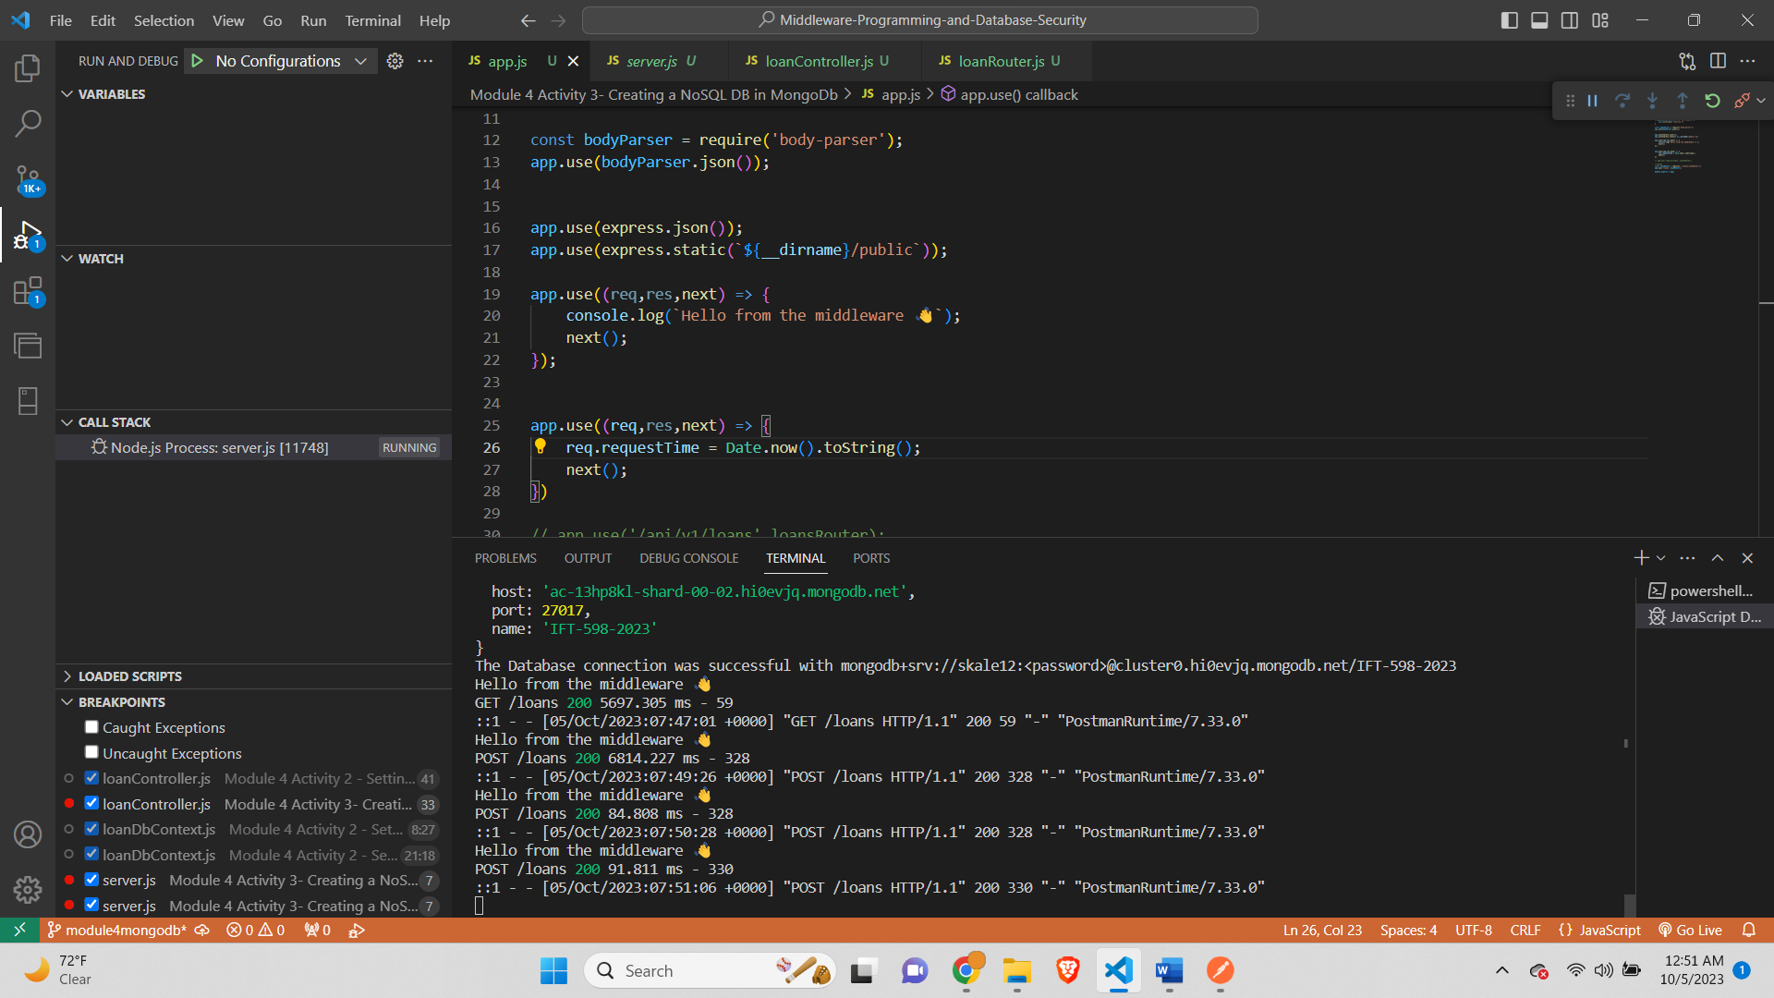

***Screenshot of the MongoDB Atlas showing successful addition of the 2 loans***

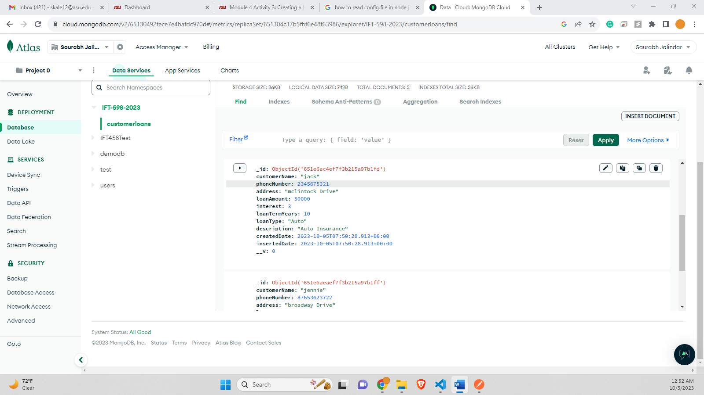

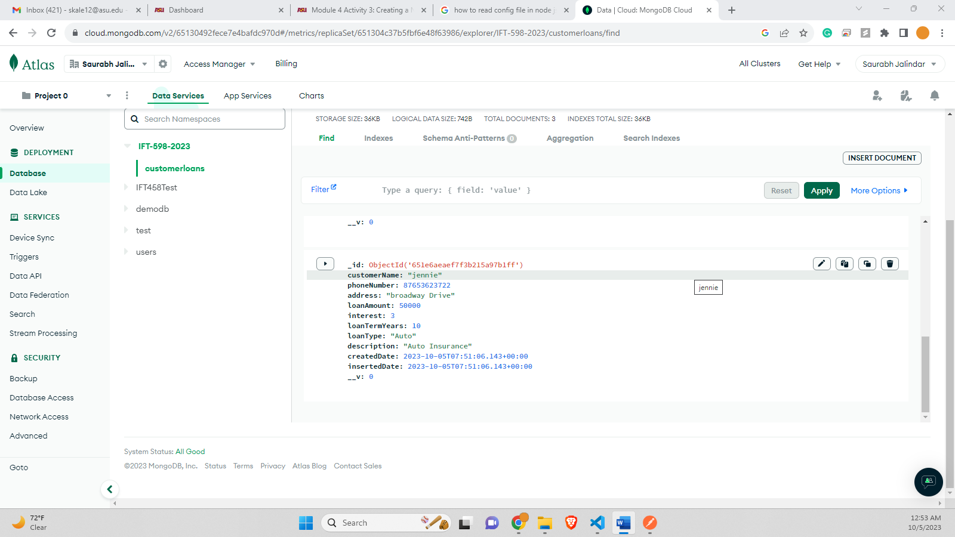

# **Step 10 – Gel all Loans**

*Screenshot of the Postman and MongoDB Atlas showing all Customers*

*All 3 documents from the collection are successful via the /loans end point as shown below –*

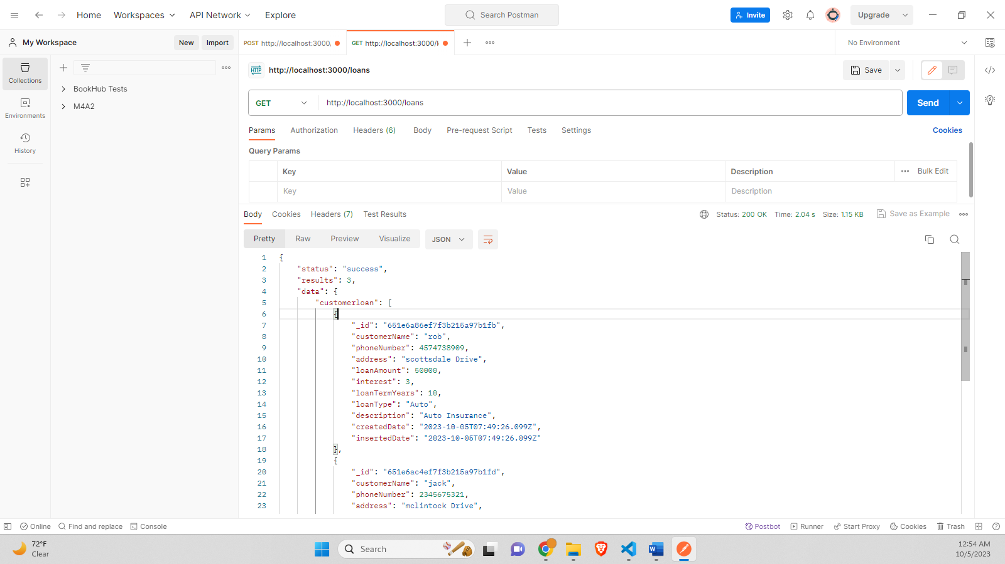

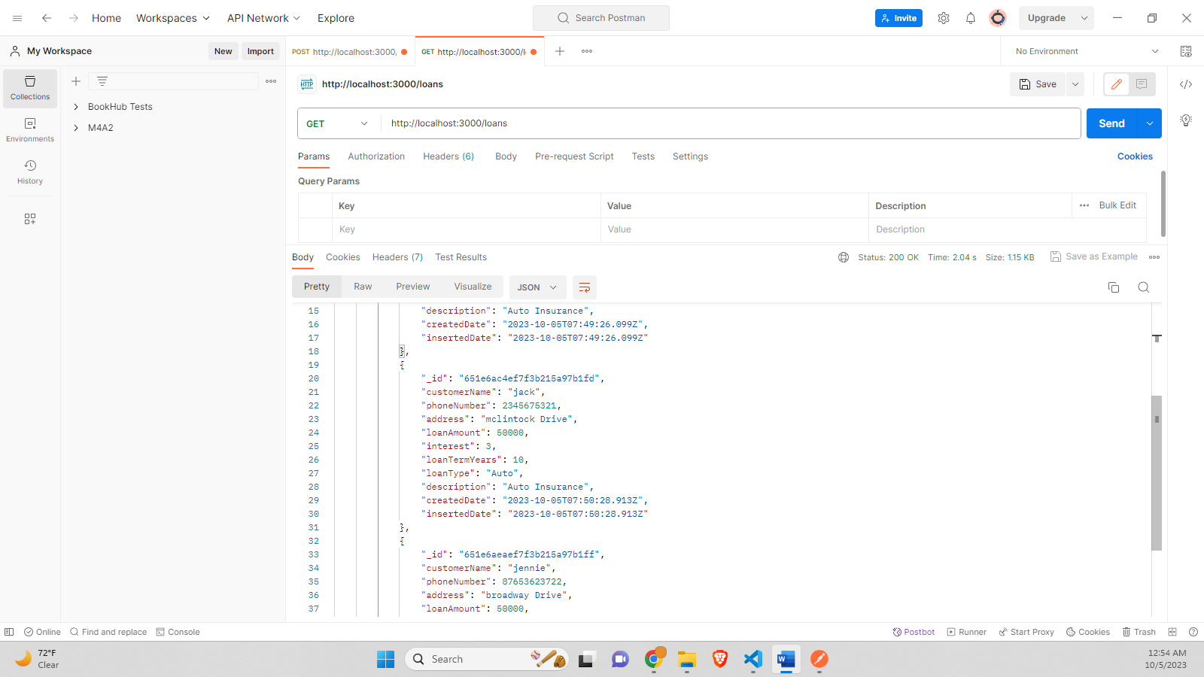

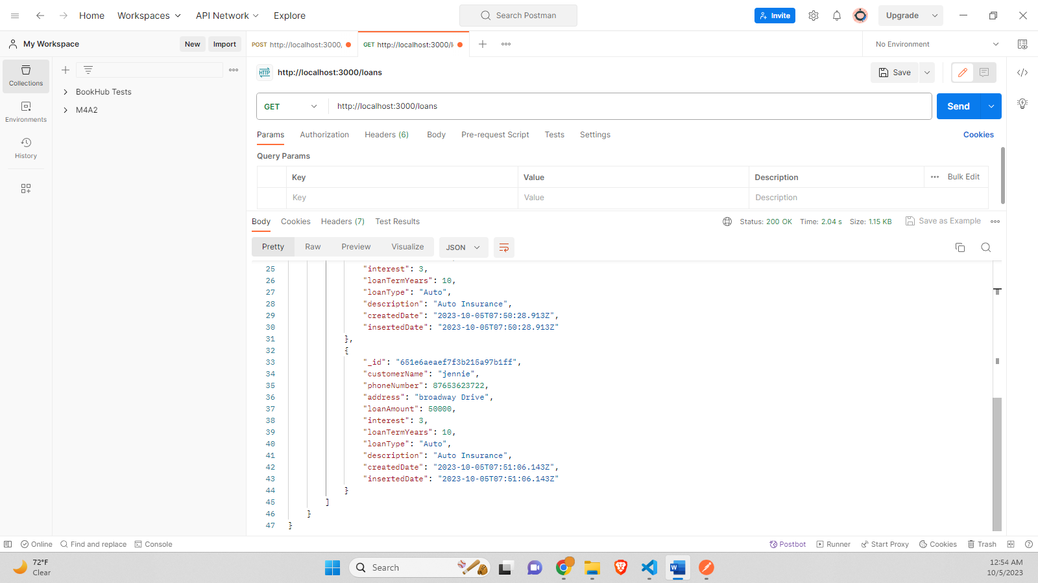

**Object-**

{

    "status": "success",

    "results": 3,

    "data": {

        "customerloan": [

            {

                "_id": "651e6a86ef7f3b215a97b1fb",

                "customerName": "rob",

                "phoneNumber": 4574738909,

                "address": "scottsdale Drive",

                "loanAmount": 50000,

                "interest": 3,

                "loanTermYears": 10,

                "loanType": "Auto",

                "description": "Auto Insurance",

                "createdDate": "2023-10-05T07:49:26.099Z",

                "insertedDate": "2023-10-05T07:49:26.099Z"

            },

            {

                "_id": "651e6ac4ef7f3b215a97b1fd",

                "customerName": "jack",

                "phoneNumber": 2345675321,

                "address": "mclintock Drive",

                "loanAmount": 50000,

                "interest": 3,

                "loanTermYears": 10,

                "loanType": "Auto",

                "description": "Auto Insurance",

                "createdDate": "2023-10-05T07:50:28.913Z",

                "insertedDate": "2023-10-05T07:50:28.913Z"

            },

            {

                "_id": "651e6aeaef7f3b215a97b1ff",

                "customerName": "jennie",

                "phoneNumber": 87653623722,

                "address": "broadway Drive",

                "loanAmount": 50000,

                "interest": 3,

                "loanTermYears": 10,

                "loanType": "Auto",

                "description": "Auto Insurance",

                "createdDate": "2023-10-05T07:51:06.143Z",

                "insertedDate": "2023-10-05T07:51:06.143Z"

            }

        ]

    }

}

# **Step 11 – Get a Specific Loan by Id**

***Screenshot of the Postman request and response***

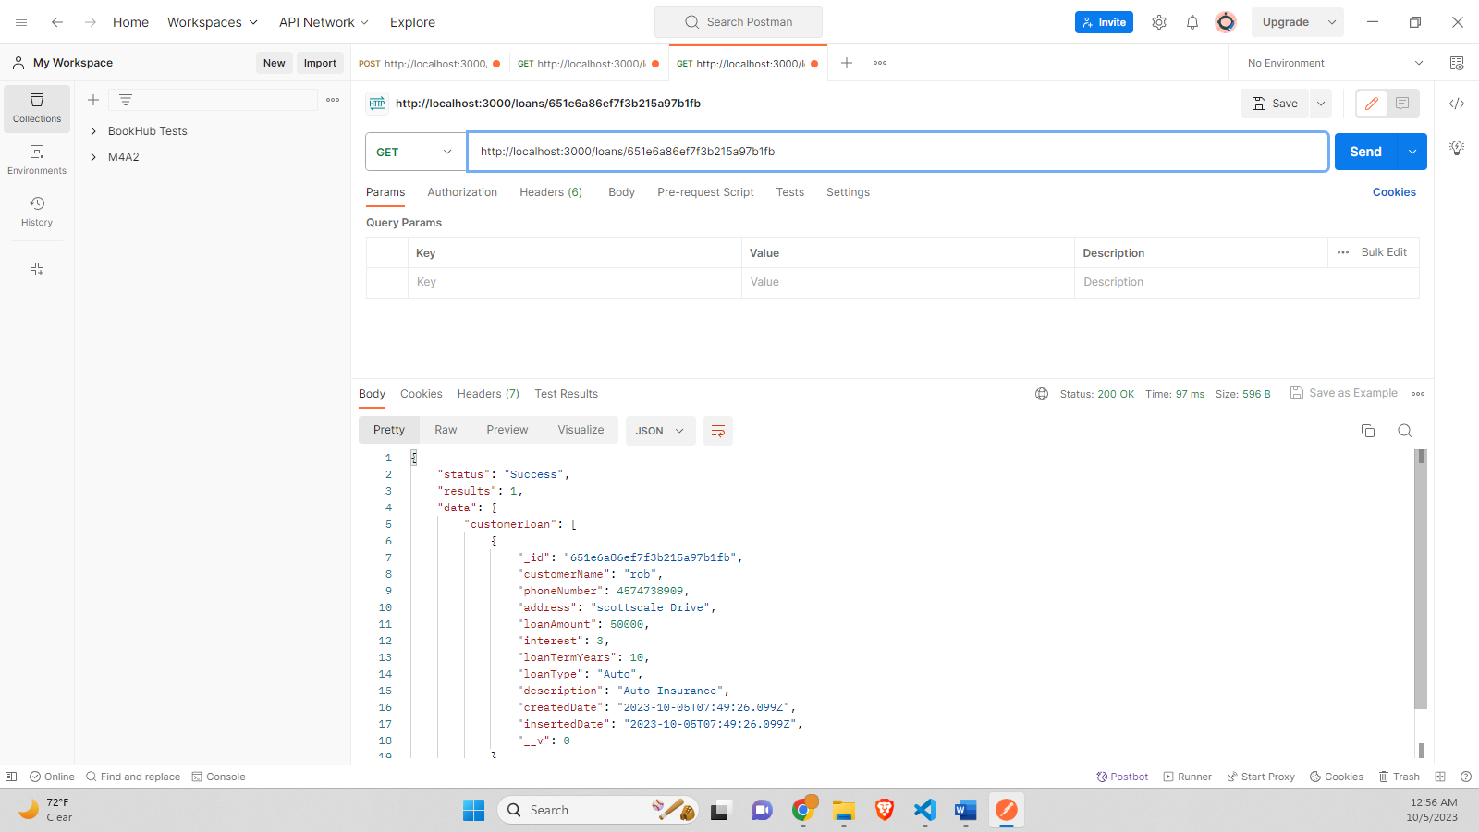

# **Step 12 – Change an Existing Loan (POSTMAN) Change an existing Loan by using the PUT verb. Then change the value of the JSON object. The URL is the same as when we fetched the specific Loan.**

*Screenshots of the document before change (POSTMAN & Atlas MongoDB)*

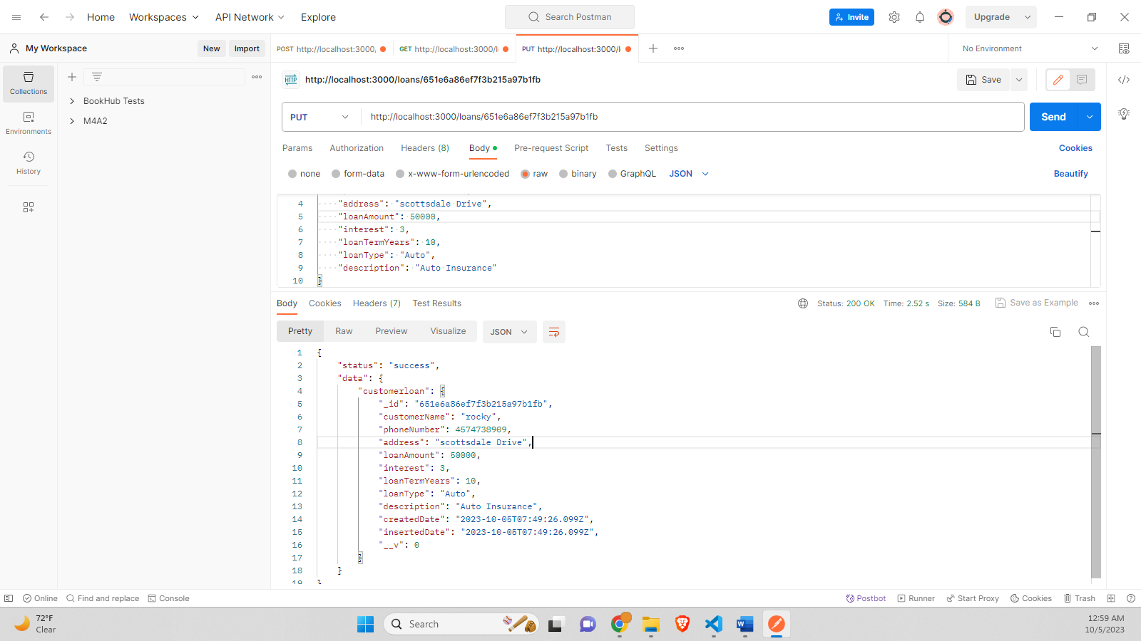

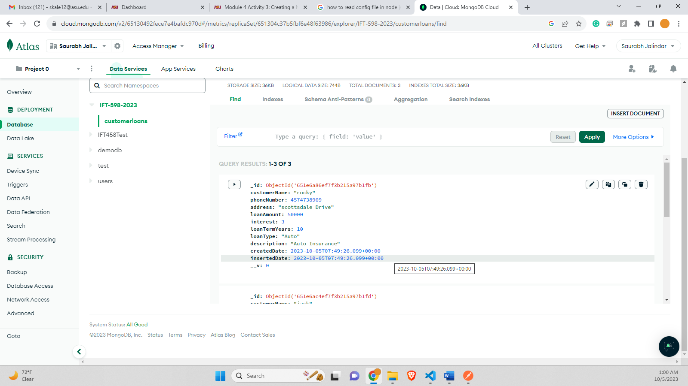

# **Step 13 – To delete a loan, we only need to change the verb to DELETE. We can verify that the user is gone by fetching all the loans. Now Verify that you have a fully working express backend connected to a MongoDB database.**

*Screenshot of the Postman showing successful deletion of the document. Response 204.*

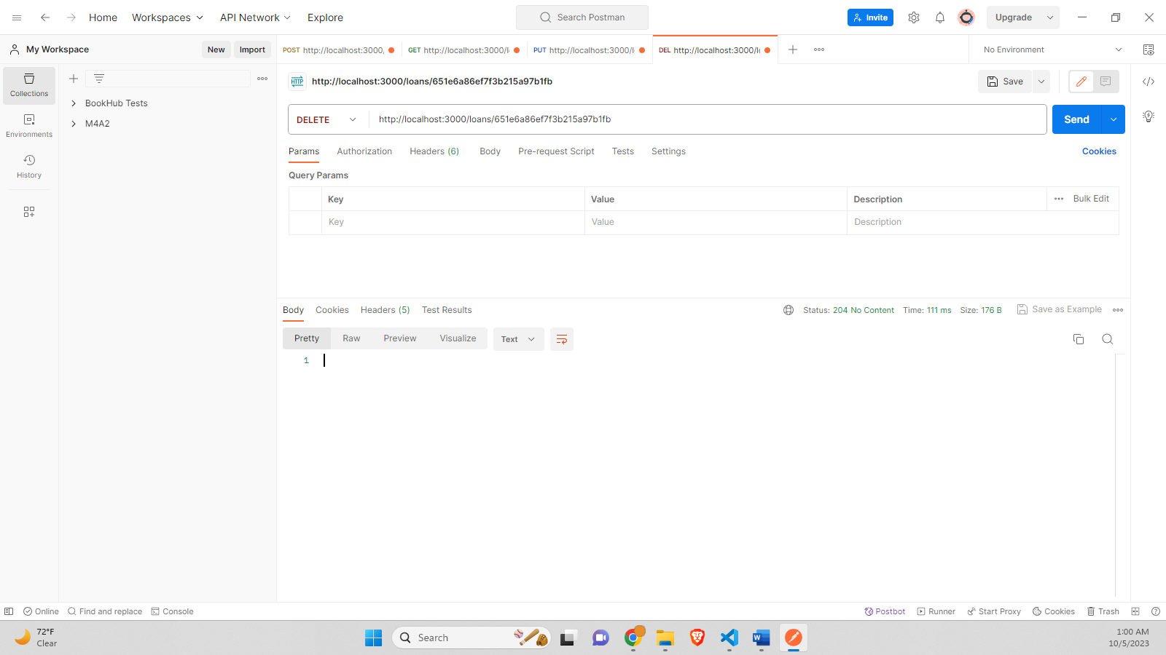

***Screenshot of the Postman verifying if a document with the id still exists or not. Output as expected. No document found.*** 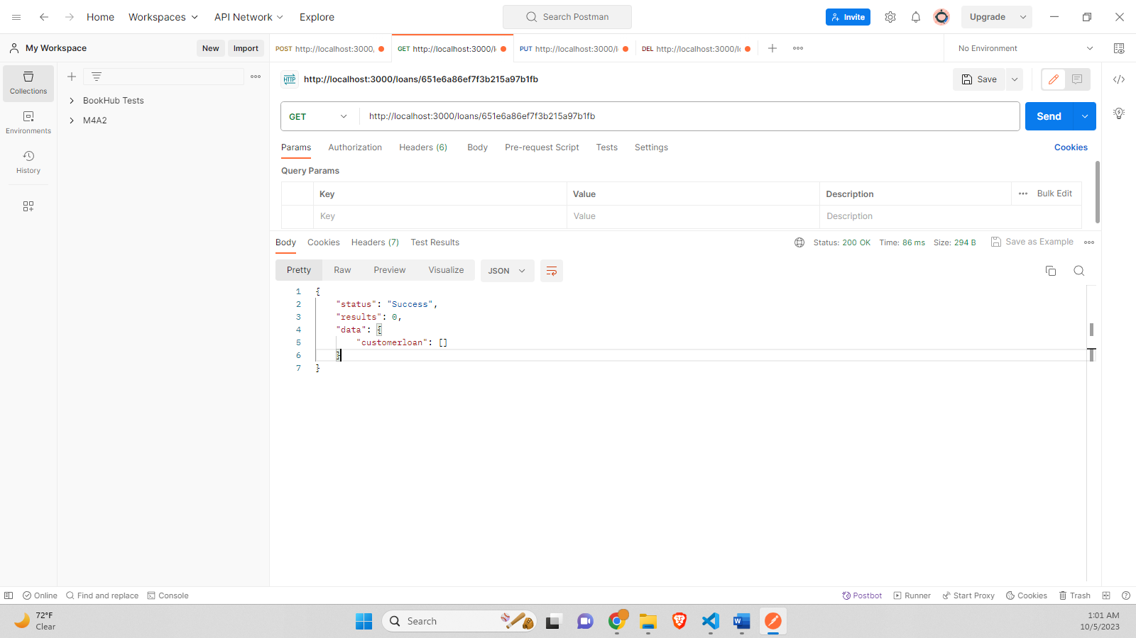

***Screenshot of the MongoDB Atlas – displaying 2 queries, previously it was 3.***

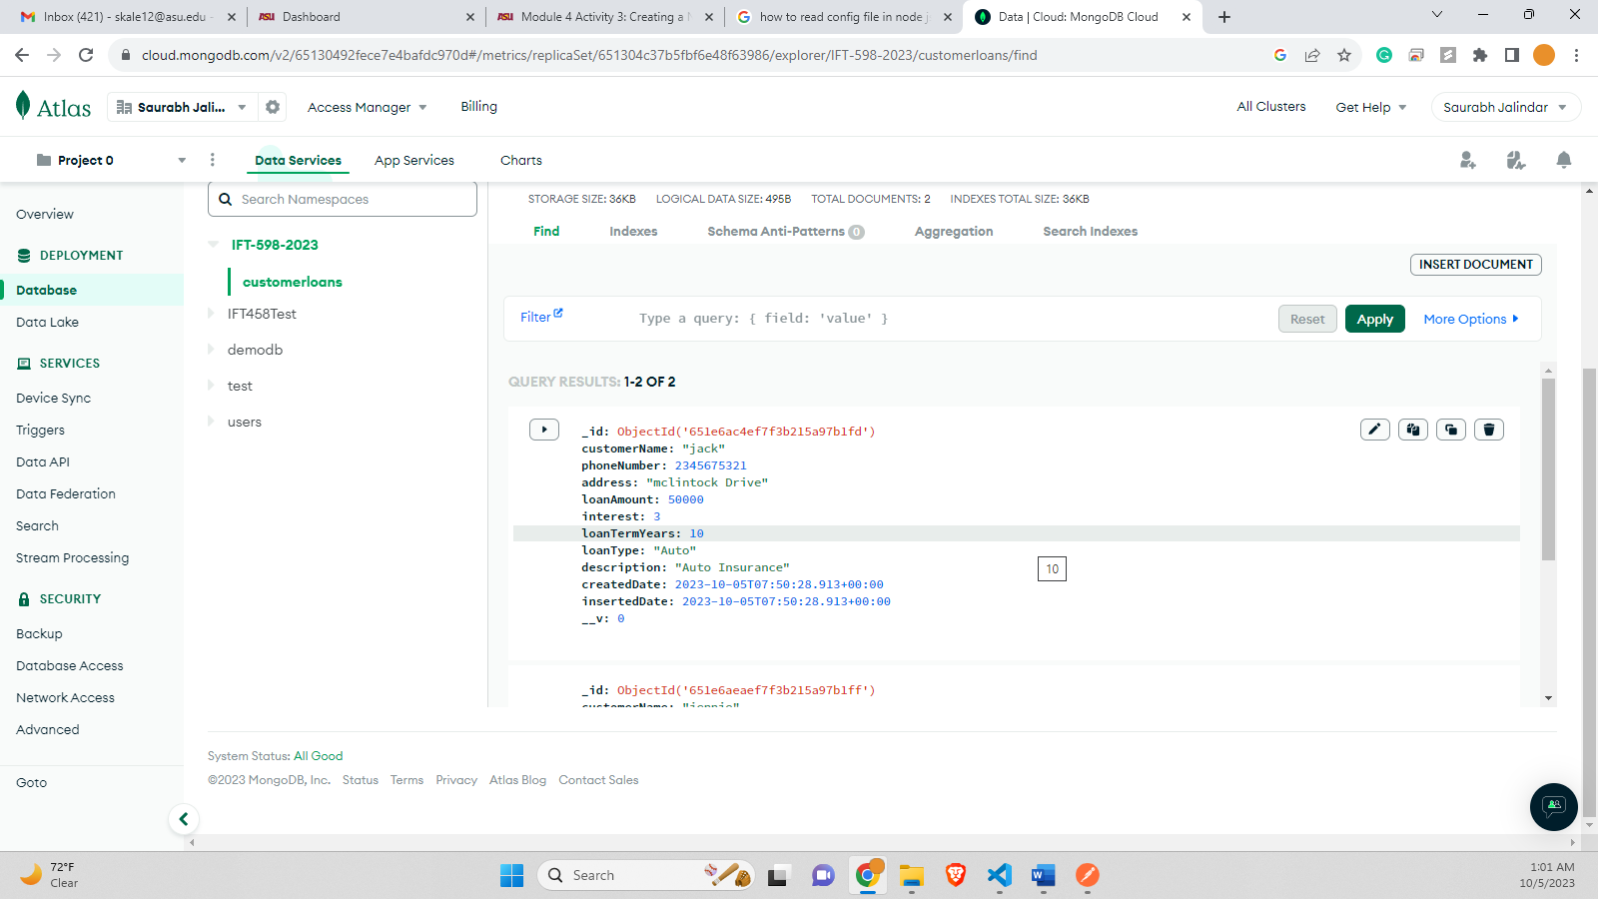

# **Git Repository-**

https://github.com/skale2022/Middleware-Programming-and-Database-Security